Governance and Communication
In the Northwest Territories (NWT), the Education Act gives District Education Authorities (DEAs) and Divisional Education Councils (DECs) the legislative authority (legal power) to provide leadership and guidance to the educational community.
NWT DEAs and DECs provide each NWT community with the authority to meet the educational and cultural needs of students in the NWT in the JK-12 education system.

WHAT IS A DISTRICT EDUCATION AUTHORITY?
The District Education Authorities (DEAs) are composed of elected and/or appointed individuals who represent their community’s interests in the planning and delivery of educational programming in their school(s).

WHAT IS A DIVISIONAL EDUCATION COUNCIL?
Each Divisional Education Council (DEC) is composed of one DEA member from each community within the region. There may be additional members representing regional organizations who also sit on the DEC. The DEC is jointly responsible for the governance and direction of schools in their region.
DECs have been established for the:
- Beaufort Delta
- Sahtu
- Dehcho
- South Slave
- Commission scolaire francophone des Territoires du Nord-Ouest
The Tłı̨chǫ Community Services Agency (TCSA) operates with the authority of a DEC and each Tłı̨chǫ community has representation on the TCSA. However, each Tłı̨chǫ community does not have a DEA.
In Yellowknife, the Yellowknife Education District No.1 (YK1) and the Yellowknife Public
Denomination District (Yellowknife Catholic Schools (YCS)) operate with the authority of a DEA. These are the only two education bodies with the ability to raise operating funds through taxation. The Dettah and Ndilǫ DEAs are the most recently established education bodies and they contract their superintendency through YK1.

WHAT IS AN EDUCATION BODY?
DEAs, DECs, and the TCSA are considered Education Bodies and are referred to as such in the Education Act.

WHAT IS A SCHOOL BOARD?
School boards, as a legal entity, do not exist in the NWT. However, the term “school board” is sometimes used to describe a DEA/DEC and office staff.

WHERE DO DEAs AND DECs GET THEIR AUTHORITY?
DEAs and DECs get their authority from the Education Act of the Northwest Territories, passed by the Legislative Assembly in 1995, which came into effect on July 1, 1996. The Act provides communities with more independence to develop educational programming in the JK-12 system so that the culture and language of each community can be reflected in its school(s).

KEY RESPONSIBILITIES OF THE DEAs
- Establish goals, objectives and local policy for the DEA
- Make budgetary decisions
- Advise the Superintendent in the hiring of education and school staff
- Operate within federal, territorial and municipal laws
- If a DEC is established in the region, choose a DEA representative who will sit on the DEC
- Act as liaison between the school and community

KEY RESPONSIBILITIES OF THE DECs (ANDYELLOWKNIFE DEAs)
- Hire the Superintendent as their only employee
- Establish goals, objectives and local policy for the DEC
- Make budgetary decisions
- Operate within federal, territorial and municipal laws
- Only the Chairperson communicates with the Minister of ECE

GOVERNANCE AND ADMINISTRATION – HOW ARE THEY DIFFERENT?
There is an important difference between governance and administration and how these roles are carried out by DEA and DEC members or the Superintendent and Principals.
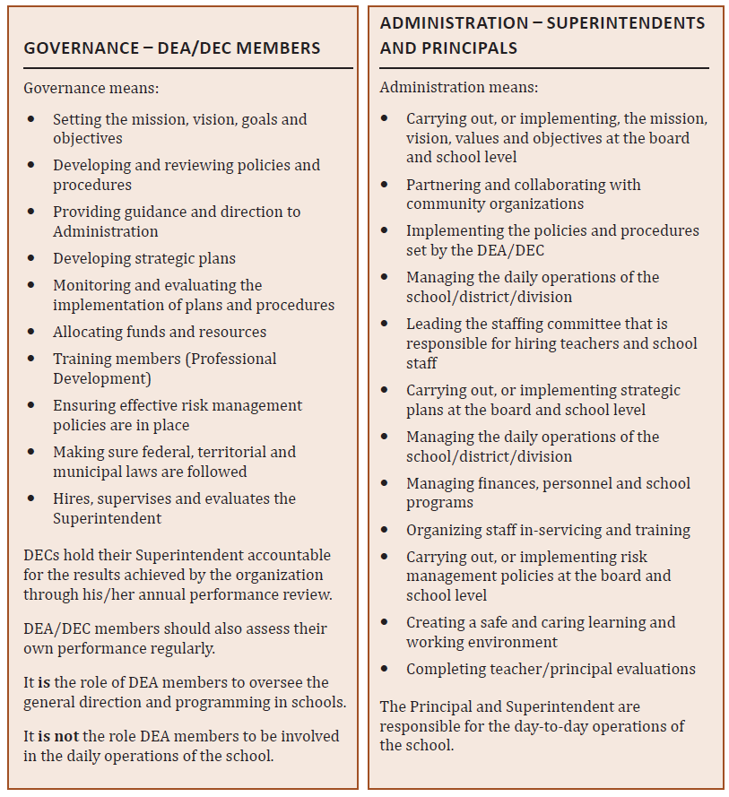

HIRING AND EVALUATING EDUCATION STAFF
The DEC is responsible for hiring, supervising and evaluating the Superintendent.
Hiring practices vary between regions. Many establish a hiring committee, which may include:
- Superintendent
- Principal/Vice-Principal
- DEA/DEC member
- Human Resources representative
The DEA does not supervise or evaluate school staff (Figure 3).
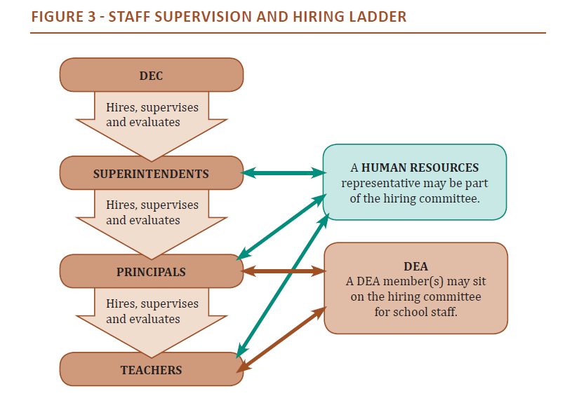

LINES OF COMMUNICATION
Open and respectful communication between all members is very important. There are protocols (rules) which must be used when communicating beyond the DEA/DEC (Figure 2).
