Welcome from the Minister of Education, Culture and Employment

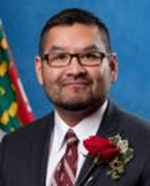
Welcome to the Northwest Territories! I am pleased that you have chosen to live and work with us, and I welcome you to your new position.
Education is evolving to meet the needs of 21st century students who live in an ever-changing world. Globally, people are rethinking the process of education which has the potential to fundamentally change the school landscape. In the Northwest Territories, the Education Renewal strategy is well underway. The goals and commitments for the future of education in the NWT are outlined in Directions for Change, the Education Renewal Framework. This document is intended to guide education in our territory for the next 10 years and beyond.
Each of your students has unique gifts and, as a teacher, you will be an integral part of their discovery and development of these gifts. NWT culture-based education supports a culturally responsive approach to education and the traditional teachings of northern Indigenous peoples. As well, the Inclusive Schooling program ensures access to quality education for all students by effectively meeting their diverse needs in a way that is responsive, accepting, respectful and supportive. You have a crucial role in teaching the whole child to become a capable person.
Your home community will offer you unique learning opportunities, whether you are teaching in a larger or a smaller centre. Participating in community events, learning about the cultures and languages of the region in which you reside and getting to know each of your students and their families will develop your appreciation of the students in your class and life in the Northwest Territories. As you connect with your community, gain knowledge of your environment and grow, your experience will be more enriching, rewarding and enjoyable. As a member of the northern teaching community, you are now part of a bigger family. I hope you fully enjoy your time here and come to call the NWT your home.
I wish you all the best in the coming school year.
Honourable Alfred Moses,
Minister of Education, Culture and Employment

Thank you to all who have contributed to this work over the past years.
Many experienced educators provided essential feedback and suggestions for improvement.

We will continue to collect feedback and suggestions, and we appreciate your input.
Northwest Territories Induction Package For New Hires.

Northwest Territories
Induction Package
For New Hires

Following Ed Renewal, it became evident that the Teacher Induction and Mentorship Program also needed reform. Induction and Mentorship are now delivered separately but remain housed as one under the Educator Induction and Mentorship Program with mentorship being a major component of the Induction program. The Educator Induction Program and the Educator Mentorship Program are still linked in content and purpose: to support a new educator in developing relationships, enhancing confidence and strengthening instructional practices.
If you have any question, please contact the Educator and Mentorship Programs Coordinator:
Colleen Eckert
Professional Development and Instructional Improvement Coordinator
Education Operations and Development
Department of Education, Culture and Employment
Government of the Northwest Territories

Phone: 867-767-9353, ext. 71262
Fax: 867-873-0338

Table of Contents

Definitions 6
NWT JK-Grade 12 Education Renewal 10
Foundational Statements 10
The NWT Educational Renewal Initiatives 13
Context for Change 15
The Global Need for Change 16
The NWT’s Need for Change 17
The Current NWT Context 19
NWT Educational Directives 26
NWT Ministerial Directive on Inclusive Schooling 27
Indigenous Language and Culture Based Learning 38
Early Childhood Education 48
Quality Teaching and Learning 49
Student Assessment, Evaluation, and Reporting (SAER) 50
Classroom Assessment Approaches 52
NWT Educator Induction 56
Importance of Teacher Induction Mentorship 57
Educator Induction and Mentorship Roles and Responsibilities 59
NWT Educator Induction Program 61
Pre-Orientation 62
Orientation 63
Systemic Sustained Supports 65
The NWT Mentorship Program 67
APPLICATION FOR MENTORSHIP 69
Sample Mentorship Plans 72
Resources 77
NWT Education Act 78
Teacher Growth and Evaluation 78
Principal Growth and Evaluation 80
NWT Teacher Qualification for Certification 83
Professional Development (PD) 89
Advice for Beginning Teachers 91
Advice from NWT Teachers 93
Resources 94
Internet Sites 95
References 96

Definitions
Accommodation: Providing accommodation means providing measures that allow students to best gain access to and achieve success with expected learning outcomes, including those who experience obstacles to learning and those who require enriched opportunities for learning. Accommodations may include changing the teaching process, learning environment, time demands, assistance, evaluation and/or the ways in which a student demonstrates learning. Accommodations are recorded on a Student Support Plan yet do not represent changes to the expected learning outcomes as stated in curricular documents.
Beginning teacher: A beginning teacher is a teacher who is in the first two years of the profession.
Commission scolaire francophone: A publicly elected body drawn from French right- holders of Hay River and Yellowknife. The Commission makes decisions on planning, operations and staffing at their two community schools. The Commission scolaire francophone operates as the Divisional Board of Education for French minority language education in the Northwest Territories.
Common learning environment: This term refers to an inclusive environment where instruction is designed to be delivered to students of mixed ability and with their peer group in the community school, while being responsive to their individual needs as a learner, and used for the majority of the students’ regular instruction hours.
Department of Education, Culture and Employment (ECE): This department in the Government of the Northwest Territories consists of the following divisions: Aboriginal Languages and Learning Secretariat; Culture and Heritage; Education Operations and Development; Early Childhood and Development; Francophone Affairs Secretariat; Health, Wellness and Student Support; Teaching and Learning; Public Library Services; Income Security Division; Corporate Management and Labour Development Standards.
Differentiated Instruction (DI): Differentiated Instruction is an important best practice in education that recognizes and supports individual differences in learning, wherein teachers actively plan and teach in order to address the diverse learning needs of their students. It is based on the understanding that students will attain learning outcomes by varying routes, at differing paces, while requiring a variety of supports. Aspects of teaching and learning that may be differentiated include: content, product/demonstration of mastery, instruction, assessment, task, grouping, resources, and/or process. Curricular objectives remain constant, while the teaching practices are flexible and designed to match student learning needs.
District Education Authorities (DEA): DEAs are composed of elected and/or appointed individuals who represent their community’s interests in the planning and delivery of educational programming in their school(s).

Divisional Education Councils (DEC): Each DEC is composed of one DEA member from each community within the region. There may be additional members representing regional organizations who also sit on the DEC. The DEC is jointly responsible for the governance and direction of schools in their region. DECs have been established for the following regions:
- Beaufort-Delta
- Dehcho
- South Slave
- Sahtu
- Commission scolaire francophone des Territoires du Nord-Ouest

The Tłı̨̨̨̨̨chǫ Community Services Agency (TCSA) operates with the authority of a DEC and each Tłı̨̨̨̨̨chǫ community has representation on the TCSA. However, each Tłı̨̨̨̨̨chǫ community does not have a DEA. In Yellowknife, the Yellowknife Education District No.1 (YK1) and the Yellowknife Public Denomination District (Yellowknife Catholic Schools (YCS)) operate with the authority of a DEA. These are the only two education bodies with the ability to raise operating funds through taxation. The Dettah and Ndilǫ DEAs are the most recently established education bodies and they contract their superintendency services through YK1.
Education body: DEAs, DECs, and the TCSA are considered education bodies and are referred to as such in the Education Act.
Education program: This term refers to the program of education from kindergarten to grade 12 based on the curriculum established by the Minister. Students may follow a Regular Education Program (with or without accommodations), a Modified Education Program, or an Individual Education Program.
Enrichment: Providing enrichment refers to extending the learning outcomes to ensure that students are appropriately challenged; a form of accommodation.
Homebound students: Students who are homebound are those who are required to stay home and not attend school at the request of a medical doctor.
Inclusive Schooling: Inclusive Schooling ensures that students can access the education program, and required supports, in a common learning environment in the student’s home community.
Individualized Education Program/Plan (IEP): An individualized Education Program is student-specific program outlined in an Individualized Education Plan (IEP). This plan is a comprehensive written education plan with annual student outcomes and shorter-term objectives, determined through a collaborative process, driven by the strengths and needs of the student; it may or may not include learning outcomes articulated in NWT curricula. A student on an IEP usually requires supports, accommodations, facilities, resources and/or equipment required beyond those required by his/her peers.
Induction: Induction is the process of providing a support system for the new or beginning teacher. This support system usually includes an orientation to the community, a formal mentoring program, and professional development to enhance teaching skills. NWT Induction for new and beginning teachers also currently includes an optional territorial orientation held each August in Yellowknife called “New to the NWT” Educators’ Conference (N2NEC).
Instructional Strategies: techniques teachers use to help students become independent, strategic learners. These instructional strategies become learning strategies when students independently select the appropriate ones and use them effectively to accomplish tasks or meet goals.
Local Receiving Officer (LRO): Each of the NWT’s 49 schools and 8 DECs/School Boards identifies a volunteer who is the key communicator with Northwest Territories Teachers’ Association (NWTTA). Their purpose is to share information between members and the NWTTA Central Office, as well as Regional Presidents.
Mentorship: Mentorship is a dynamic process which builds on the needs of the beginning or new teacher, the strengths of the mentor and the relationship between the two. This relationship must be flexible and provide formal and informal interactions.
Modified Education Program: A Modified Education Program is developed for students who are documented as working significantly above or below grade level in one or more subjects, yet retain the learning outcomes articulated in NWT curricula. The curricular learning outcomes are selected from the working grade level and used to guide instruction for the Modified Program. The Modified Program is based on student strengths, needs and interests and may include modified individualized learning goals, instructional methods, methods of practice and evaluation procedures, consistent with the principles of differentiated instruction. The Modified Program is recorded in a Student Support Plan (SSP).
New teacher: A new teacher has previous teaching experience but is in his/her first year of teaching in the NWT. Several NWT schools mentor all staff new to the building.
Northwest Territories Teachers’ Association (NWTTA): The Teachers’ Association provides information and services for all teachers in the NWT. Members of the NWTTA work under three separate contracts: Government of the Northwest Territories (GNWT), Yellowknife Catholic Schools and Yellowknife District No. 1 Education Authority.
Other Professionals: Within NWT education, Other Professionals includes related service providers such as Occupational Therapists, Speech-Language Pathologists, Physiotherapists, Social Workers, Addictions and Mental Health Counsellors, Educational Psychologists, and Pediatricians.
Program Support Teacher (PST): The PST in an NWT school is an experienced and skilled teacher who provides direct collaborative support to classroom teachers as they develop instructional strategies to meet the needs of students.
Regular Education Program: A Regular Education Program is determined by the learning outcomes articulated in NWT curricula for a specific grade level.
School-based Support Team (SBST): This team is co-led by the school administrator and Program Support Teacher(s) that provides support to classroom teachers with instructional issues, strategy development and problem-solving. The team coordinates the utilization of school personnel and other resources to support teachers and students. The school-based team may seek the assistance of other professionals or community supports, as appropriate.
School Board: School boards, as a legal entity, do not exist in the NWT. However, the term “school board” is sometimes used to describe a DEA/DEC and office staff.
Student Support Plan (SSP): A Student Support Plan is a record of supports for learning which documents accommodations or modifications required for a student to best experience success with their programing. The SSP may change at any time to best reflect student needs and successes. Different kinds of Student Support Plans exist: Regular Education Program with Accommodations for Difficulty (K-12); Regular Education Program with Accommodations for Enrichment (K-12), Modified Education Program – Below Grade Level (K-9); Modified Education Program – Above Grade Level (K-9)
Support Assistant (SA): A Support Assistant is an individual working in the school to support classroom teachers in meeting the instructional and personal needs of students.
Supports: This term refers to any additional service, strategy or resource provided to enhance student learning or help an individual student overcome barriers to learning. Supports are services beyond those provided to all students as part of the overall school program.
Temporary residency: This term refers to a temporary situation where a student is residing in a treatment centre/group home operated by the NWT Department of Health and Social Services (HSS) such as:
- Youth Justice Facilities operated by the NWT Department of Justice
- Medical/long-term care facilities operated by HSS
- Medical or treatment facilities outside of the NWT approved by HSS
- A temporary foster placement

NWT JK-Grade 12 Education Renewal

Foundational Statements
The foundational statements emerged from our research and engagement processes, and guide the Education Renewal (ER) initiatives.
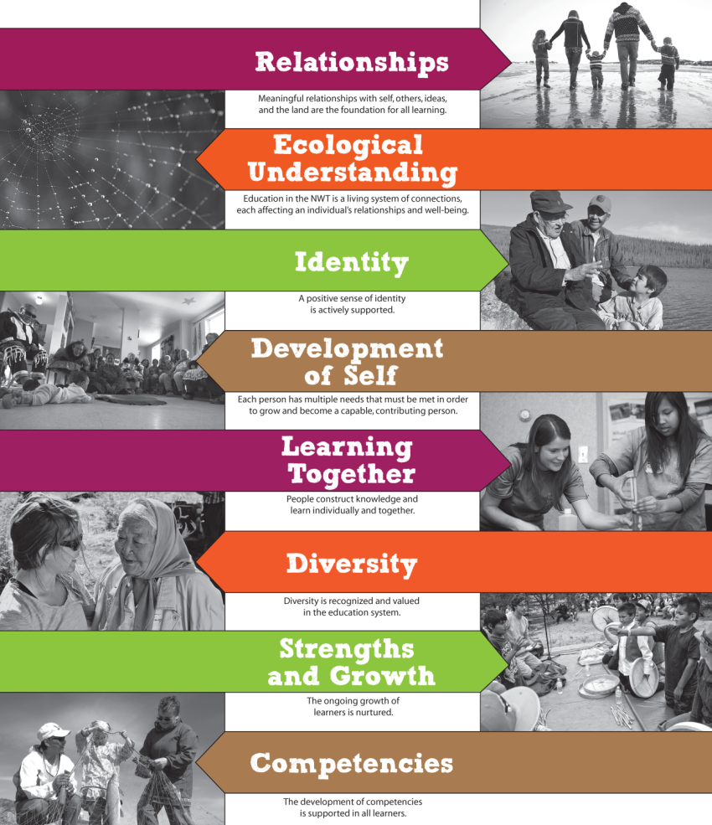

Relationships
Meaningful relationships with self, others, ideas, and the land are the foundation for all learning. The school and community are connected. The active involvement and roles of all partners- -students, family, community, school staff, educators, Indigenous Governments, business, etc. --are highly valued in the learning that occurs inside and outside school walls. Learning involves relationships with ideas, people, life experiences, languages, spirituality, and culture. All are rooted in the place where we live and learn, thus making it essential to connect to the land and people of that place. Through meaningful and respectful relationships, people can talk openly, develop a shared vision, and make decisions together on the directions of students’ learning. Students contribute to their community and to their own life-long learning when their relationship with learning is one of true inquiry and discovery.

Ecological Understanding
Education in the NWT is a living system of connections, each affecting an individual’s relationships and well-being. Education in the NWT can be compared to an ecosystem. The education system is a central and complex part of the North. Every action within the living system impacts more than just the school or its students; it impacts parents, educators, communities, and the wider territory.
An ecosystem succeeds only when it is sustainable, with all parts respected and taken care of. The health of any single part of the system impacts others through the complex web of connections between them. To ensure system strength, all connections and their impacts on each other and the whole must be considered.

Identity
A positive sense of identity is actively supported. A person’s sense of identity is formed and transformed by their relationships and their understandings of the world around them. In the NWT, the land has a great influence on peoples’ identity. Northern languages, cultures, and values must be recognized by the education system so that learning connects with life experiences, spirituality, and identity, not just to facts and skills. The NWT education system must create opportunities for individuals and groups to express themselves, to feel empowered, and to apply both independence and choice in their learning.

Development of Self
Each person has multiple needs that must be met in order to grow as a capable, contributing person. People learn best when their social, emotional, physical, intellectual, and spiritual needs are met. The NWT education system must provide safe, caring, and stimulating environments to allow all learners to explore and meet their different needs. This environment will impact each person’s development of well-being, resiliency, self-worth, and ability to contribute.

Learning Together
People construct knowledge and learn individually and together. Every person and group makes unique and necessary contributions to learning. Ideas are created and grow through the different experiences, thoughts, and ways of knowing and doing contributed by each person. The NWT education system must ensure authentic and meaningful connections between learning and life and meaning and values. Learners co-construct knowledge as they inquire and problem-solve, wrestling with real-life challenges, issues, and questions that impact their community and themselves.

Diversity
Diversity is recognized and valued in the education system. When people have different social, cultural, historical, linguistic, geographic, economic, spiritual, and political backgrounds, they carry different world views, ways of learning, and ways of doing. Relationships in which people feel free to think and express uniqueness support meaningful learning and working environments. Diversity is essential, as it provides a more complete picture for understanding, constructing knowledge, and moving forward. By using the strength of these different world views, the NWT education system can meet the diverse needs of learners and communities with flexibility, equity, and respect.

Strengths and Growth
The ongoing growth of learners is nurtured. The NWT education system recognizes and respects that each person has defined experiences and strengths. The same respect for uniqueness applies to educators, groups, and communities. All learning environments, processes, and initiatives must begin with this in mind and serve to foster personal growth. We must help learners to self-evaluate and set personal challenges. We must encourage efforts and risk-taking since they generate ideas and creative solutions to problems, and foster resilience.

Competencies
The development of competencies is supported in all learners. Capable people have the knowledge, skills, attitudes, and values to work through any situation. When learners explore real life situations that push them to think, work together, and act creatively, they use and further develop these competencies. By doing so, they shape their brain’s activity and strengthen their neural connections. In an NWT education system that embraces competency-based learning, learners have ownership over learning choices and decisions. They are supported as they take responsibility for their learning and progress. In this environment disciplines are no longer fixed bodies of knowledge; they become something in which to experiment, venture into, and contribute. The teacher becomes a facilitator, a guide to the learning venture at hand.
**To find more information on GNWT Education Commitments and Initiatives please see the following link:
https://www.ece.gov.nt.ca/sites/www.ece.gov.nt.ca/files/024-renewal_framework_en_proof_2.pdf

The NWT Educational Renewal Initiatives
The NWT Education Renewal initiative (ER) began in 2012. It was driven by both a wide-spread and well-documented acknowledgement that the current approach to education in the NWT was not succeeding for many students. It was also driven by both emerging consensus in academic research and traditional indigenous understandings of how people actually learn, and how an education system might better reflect those understandings.
The initial phase of the ER process focused on a scan of northern, Canadian, and international educational research and widespread engagements with a range of audiences across the NWT. This work led us to a renewed understanding of some of the measures we should use to measure student success, and to a new vision for teaching and learning. This research and consultation process showed us that:
Students need to see the connections between their lives, what they are doing in school, and the world at large.
Students need to own their learning, behavior, and trajectory; this will engage them.
Students need to know where they come from - who they are – in order to determine who they are becoming and how they contribute.
Schools need to be the heart of communities, where all are welcome and safe, and all learn from each other.
Learning, creativity and engagement sprouts from good relationships, at all levels.
Schools are not strictly responsible for inputting knowledge into young minds; they are in the business of supporting students in their development of values, attitudes, skills and knowledge, as well as of their sense of identity and empowerment.
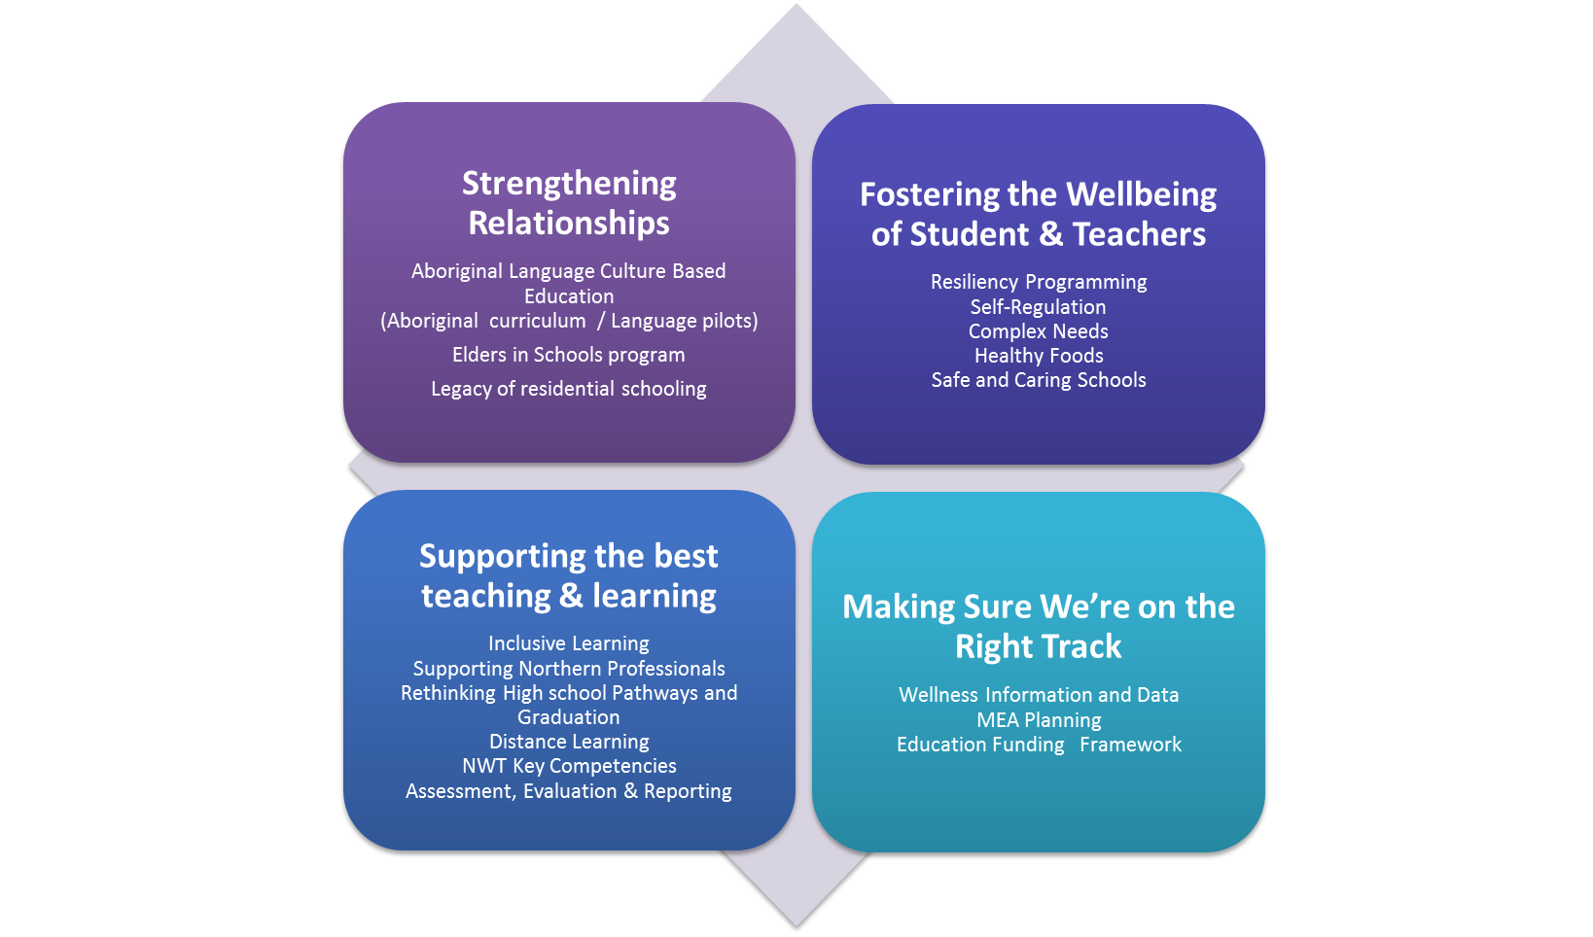

The first initiatives or projects chosen to pave the way for change in education in the NWT were carefully chosen to support what we gleaned from research, the experience of Northerners and the guiding principles we established. They can be organized under four areas of focus.

Strengthening Relationships
Examples of ER initiatives intended to address this area:
Funding to facilitate the presence of Elders in all NWT schools
Awareness training and curriculum development around the legacy of residential schooling
A renewal of the directive related to Aboriginal Culture Based Education and the funding for that directive

Fostering the Wellbeing of Students and Teachers
Examples of ER initiatives intended to address this area:
A pilot program for resiliency development in at risk students
The implementation of self-regulation in schools across the NWT
The provision of funding for healthy snacks and meals in all NWT schools
A pilot project supporting mental health and counseling in small communities.
Anti-bullying legislation, regulations, Safe School plans and programming related to healthy relationships.

Supporting the Best Teaching and Learning
Examples of ER initiatives intended to address this area:
Identifying the key competencies of Northern people, students, to help focus our programming, teaching, and assessment
Rethinking high school pathways and graduation requirements
Developing a northern distance learning platform
Offering ongoing training and professional development to our educators in areas such as mindfulness and inclusive education,
Providing up to 100 hours of time for professional activities like PD, student assessment, reporting, expertise sharing, and professional collaboration

Making Sure We’re on the Right Track
Examples of ER initiatives intended to address this area:
Collecting the right data, both around academics and health indicators
Monitoring and adjusting our pilots and projects before expanding to make sure we’re making best use of public funds and having the courage to stop those things that aren’t working

Context for Change

History of Education in the NWT
One of the first duties of any community was to educate their children to become capable^{i} people. Elders were always central to this education as they were facilitators to the children in learning knowledge, skills, attitudes, and values that they, and their community, needed in order to survive. That began to change in the 1800s.
1800s – Missionaries arrive and French or English instruction begins with a focus on religion. The creation of residential schools formalized this Euro-Canadian teaching style with many of these schools taking children away from their families – cutting them off from their language, communities, culture, and way of life.
The history and legacy of these schools are still strongly felt across the NWT and are at the root of many of the challenges we see in northern communities today, as well as in the relationships between many northern people and formal education.
1970s –NWT began to define itself as a territory, education was a key focus.
1982 – A Special Committee on Education created a new plan for an improved educational system in its final report Learning, Tradition and Change. School Boards were created and much of our current education system is based on this report, in which the values of the communities and people of the North are reflected.
1990s - District Education Authorities (DEAs) and District Education Councils (DECs) added at the community and regional levels.
Much has changed in the world and in education in the past 25 years. Education systems have the incredibly daunting task of preparing our youth for jobs that are changing rapidly, some of which do not even exist yet. What many adults remember as ‘school’ from their childhood has not remained the same. The goal of the NWT Educator Induction Program is to strengthen beginning and new to the north teachers’ knowledge of the NWT’s rich past and present to better educate all learners and prepare the youth to successfully meet the challenges of tomorrow. The purpose of the NWT Teacher Mentorship Program is to develop a beginning teacher’s sense of belonging and support their development as a teacher and participating member of the community in which they live.
i. The term capable person is being explored worldwide, including in Dene Kede – Education from a Dene Perspective (1993), where it refers to the knowledge, skills, attitudes, and values presented by Dene Elders in the hope of helping create people who have integrity in their relationships with themselves, the land, other people, and the spiritual world (p. xiv).

The Global Need for Change
One of the driving forces behind change in education is new research on how the brain works and how people actually learn. Change is also driven by new technologies which enhance learning and allow students to interact with the world and with other learners all over the globe.
Research and data show that many of the world’s current education systems are experiencing difficulty in preparing students for the demands of our fast-changing world. There is global concern with engaging students in their learning and helping them develop the knowledge and skills needed to be successful in the future. An important fundamental understanding that has evolved out of the ERI research and engagement processes is that what we believe about meeting the needs of students, in order for them to learn best, applies equally for teachers, in order for them to teach best. We know:
‘Learner’ encompasses both students and teachers, and anyone else involved in the school community or specific learning activity.
Learners need to actively participate in and be motivated by their learning.
Learners must develop not only 21st century skills and competencies but attitudes and values as well.
Easy access to online information is shifting the teacher’s role from being a holder of information and expertise, to that of a critical coach, showing students how to select, work with, and apply information in meaningful ways, to meaningful questions.
Research and experience demonstrate that effective learning happens when students direct their own learning and work together, inside and outside the classroom.
Educational research is also showing that education which considers the well-being of the whole person (cognitive, emotional, social, spiritual, and physical) can improve academic success overall. This includes supporting and teaching self-regulation, resilience, and a positive sense of identity. It is clear that to improve student success, students’ environments and experiences must be developed in a holistic way.

The NWT’s Need for Change

Aboriginal Student Achievement Education Plan
During the 2010-11 school year, NWT Indigenous, community, and youth leaders came together at Aboriginal Student Achievement (ASA) forums to explore how to address the gaps in school achievement between Aboriginal and other students. The 2011 ASA Education Plan identified four priorities:

Early Childhood Development and Care

Student and Family Support

Aboriginal Language and Culture Curriculum and Resource Development

Literacy

The ASA Education Plan has since helped to show the need to do more than simply tweak the existing system; it revealed the need to think differently about the system as a whole. As current and future partners in education, Indigenous governments are increasingly involved in discussions about education. The NWT is moving into a period where Indigenous governments, through negotiated agreements, have regained the rights of formal education for their people, and are beginning to negotiate and will ultimately exercise these responsibilities. The signing of the ASA Partnership Declaration (2011) demonstrated support and commitment to working together, which is welcomed and needed to build a stronger, relevant, NWT education system.

Small Communities
Most NWT schools are small schools that face unique challenges such as limited access to resources, inflated costs, fewer teachers, and classes with multiple grades. Additionally, it is quite difficult for small schools to offer the wide range of high school courses needed to meet the many interests, abilities, and future goals of their students. Many of these schools also need help to better reflect the culture and values of their community – within their buildings, classrooms and teachings. Many small schools also end up hiring teachers who are new to teaching, not from the North, and who may choose to stay for only a short period of time in these communities.

Indigenous Education
The understanding that genuine education is rooted in place and culture is age-old and fundamental to Aboriginal people. Culture-based education and programs developed in the NWT allow us to respect the different ways of knowing and learning of students, and better meet their needs by making the language and culture of the land foundational parts of our education system.

Accountability
The people of the NWT want and deserve an education system that is accountable, from the individual student to the entire system. This need for change was highlighted in the recommendations of the 2010 and 2012 Office of the Auditor General’s (OAG) reports. The OAG confirmed that in order to demonstrate accountability, we need to develop clear overall goals, ways to monitor our progress, and ways to know when we have reached those goals. In addition, assessment of student learning must be truthful, relevant, fair, and personal. We need careful and continuous guarantees to make sure that spending and program delivery are responsible, practical, and appropriate.

Inquiry-based Learning
The NWT needs to foster a learning environment where students are engaged in, and motivated by, learning through inquiry and exploration that is directly connected to their lives. Through our relationship with partners like Alberta (one of our major partners in education) the NWT is able to participate in making major changes that require significantly more capacity than the NWT currently has.

Data
Data collected from the fields of education and health both show disturbing differences across the territory between small and larger schools, as well as between the NWT and Canada. This data points to a very strong link between low academic achievement and poverty, and signals that the highest levels of poverty in the NWT are found in the smallest communities.

Partnerships
Some of the needed changes go far beyond what can be done in a school setting alone. Meeting these needs must involve many partners – parents, teachers, community members, as well as the supports that can be offered by various social, health, and recreational resources. Collaboration with partners and agencies in the community in which you live and developing links with external supports is vital in the success of northern learners. The increased recognition and participation of these partners is essential.
The commitment that came out of the ASA process indicated that the NWT was ready and willing to face the challenges that exist to achieve the vision of education held by the people of the North. It was a vision that was both ancient and new. It was recognized that significant, sustained change would take determination, collaboration, time, and dedicated hard work from all involved in education and in the lives of northern learners. A shared willingness to work together is part of what makes the NWT unique and the place northern people are proud to call home.
From the ASA process, a more comprehensive initiative designed to address many of the systemic issues facing education in the NWT, emerged. It took a very ambitious approach to address these issues, grounded in research and data collection, as well as through widespread engagements with educators, parents, students and Elders.
This initiative came to be known as ‘Education Renewal’ (ER), and resulted in the development of a 10 Year Framework – Directions for Change tabled in the fall of 2013. A rolling 3 year Action Plan was also developed, and continues to guide the work of ER –and education as a whole in the NWT- over the coming years. Some of the main components of this work are described on the next page.

The Current NWT Context

The Current System
The Minister of Education, Culture and Employment (ECE) is responsible for the NWT education system. This system currently consists of the Department (ECE) and nine education authorities responsible for the delivery of K-12 education in 49 schools throughout 33 communities. There are approximately 8,400 students and 800 educators in the NWT.

Early Childhood Development
Readiness for school is now measured by a child’s social, emotional, physical, cognitive, and language development. In the NWT, many children are starting school with significant developmental delays. A snapshot of children’s development in kindergarten gathered using the Early Development Instrument (EDI) indicates that over 35% of NWT children entering the school system are already significantly behind in their development. Specifically, that means that approximately 400 of the five year olds surveyed have significant delays.

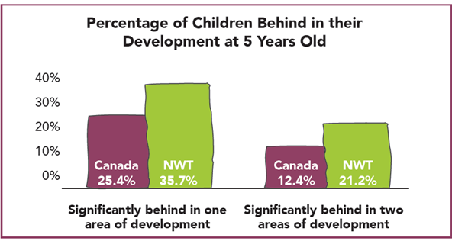
The percentage of five year olds behind in one or more areas of their development (social, emotional, physical, cognitive, or language) is as high as 60% in small communities. The number of children at risk in the area of physical development related to nutrition, sleep, and general wellbeing is over 18%, which is double the national average. The need to put supports in place even before children begin school is evident, and collaboration with other GNWT departments, as well as parents, families and communities is vital.

K-12 Schooling
Student support program data for 2010-11 shows that over 25% of NWT students are not at the academic level they should be for their age. In smaller communities, the number of students below grade level is closer to 50%. NWT data indicate a decrease in student achievement as students get older, further demonstrating an urgent need for changes to our current education system, including earlier interventions and support.

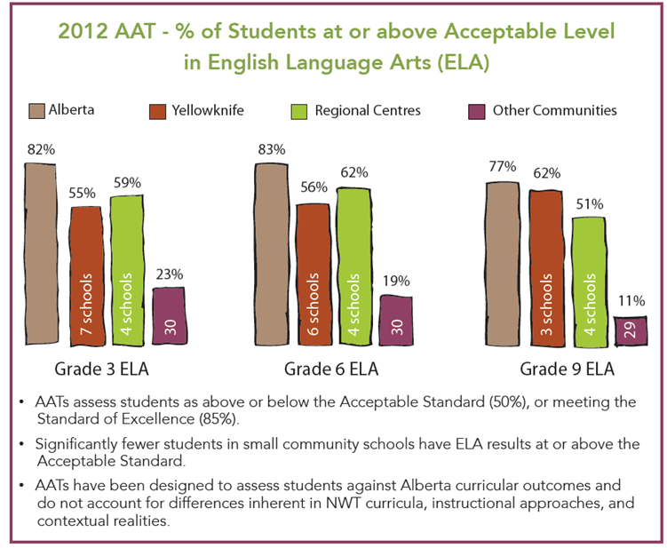
Overall, NWT students are not achieving at the same level as the rest of Canada. As measured by Alberta Achievement Tests (AATs), there are students struggling in all NWT communities, including Regional Centres and Yellowknife. A big gap exists, however, between the achievement of Indigenous students and other students, specifically in small community schools where the student population is close to 100% Indigenous.

NWT High School Graduates in 2016
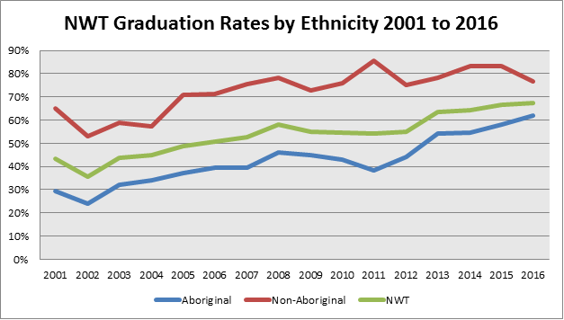
In the NWT, our high school statistics (which vary somewhat from year to year, given our small student population) indicate that slightly more than 60% of Indigenous students and slightly less than 80% of non-Indigenous students graduated in 2016.
These differences in levels of educational achievement are likely to find some of their roots in the legacy of residential schooling and are also linked to bigger challenges which must be overcome in the personal, family, and community lives of the future adults and leaders of the NWT. The recent work of the Truth and Reconciliation Commission (TRC) and the development of northern teaching and learning resources addressing this legacy are important parts of a new beginning in the NWT. The Framework for Early Childhood Development in the NWT (2013), Building on the Strengths of Northerners (2013) and Healing Voices (2013) also address these issues, which will be further supported through the Education Renewal process.
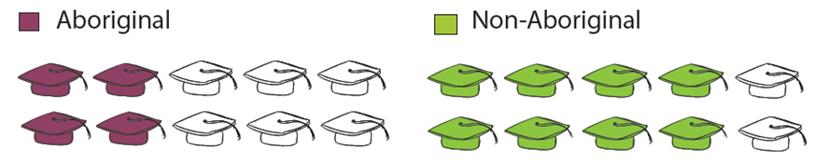

Attendance
In the 2011-12 school year, the NWT’s average student attendance was 84%. Attendance rates are even lower in small communities.
At that rate, by grade 4 the average NWT student has already missed half a year of school, or 2 full years by grade 10. Non-attendance is clearly an urgent concern that must be addressed immediately.
Age 5
Age 15
80% Attendance =
MONDAY
TUESDAY
WEDNESDAY
THURSDAY
FRIDAY
Missing 1 day per week
Grade 10
Grade 9
Grade 8
Grade 7
Grade 6
Grade 5
Grade 4
Grade 3
Grade 2
Grade 1

100% 80%
Losing up to 1 year of school for every 5 years
leaving students 2 full years behind by the time they are 15 years old
Research indicates that the issue of nonattendance is more complex, as are the reasons underlying it. In fact, non-attendance can be thought of as the symptom to a much deeper condition in an education system that needs renewal and innovation in order to be relevant and motivating to students in the 21st century

Placement of Students with their Age-peers
The practice of Inclusive Schooling in the NWT enables all students to participate within a common learning environment shared amongst age-peers. In any given classroom, there are students with a variety of strengths and challenges. Guided by the NWT Ministerial Directive on Inclusive Schooling (2016), in our territory students are placed with age-peers throughout JK-9 and provided with tailored supports and programming, most often documented on the Student Support Plan or Individual Education Plan.
This approach requires educators to adapt instructional practice and student programming to meet the student at their current level so that progress can be made by each individual. There is no policy against ‘holding back’ or ‘accelerating’ an individual student. The best interests and needs of the student are the guiding principles that should determine how a student advances in their academic pathway.

Northwest Territories
The Northwest Territories is a unique place to live. The time in which we live means that although we are located very far north, we are able to access many things that were impossible to get in the north even just 10 years ago. There are many things about our territory that make it very unique from the rest of Canada, however.

Territorial Political Governance
The hallmark of politics in the Northwest Territories is that it operates as a consensus government system. Candidates for election to the territorial legislature do not stand as members of a political party; they are elected as independents. The 19 elected Members of the Legislative Assembly (or MLAs) first select the Speaker of the House and then the Premier by way of a secret ballot, rather than on the basis of party affiliation. The Premier then selects from the MLAs six Ministers to form his/her Cabinet and gives them the different portfolios.
The eleven MLAs who are not in Cabinet are referred to as “regular members” and form a sort of unofficial opposition responsible for holding the government accountable and responsive to the people of the NWT. The eleven regular members hold the balance of power. Cabinet cannot ignore the majority. However, consensus government DOES NOT mean that decisions must be unanimous for motions to pass and legislation to be enacted. A majority vote wins. There is a transparency in territorial governments not seen in provincial government.

Difference Between the Provinces and Territories
The two major differences between the legislative powers of territories and that of provinces are the control over the management and sale of public lands and the power of the provinces to amend their constitutions.
Another difference is the significance of devolution – the decentralization of some powers, functions, responsibilities and resources to the Regional/Municipal/Local Governments.
Should the Northwest Territories wish to pursue provincial status, it will be necessary to amend the Constitution of Canada. This will require consent of the Parliament of Canada and a double majority from the provinces – seven of ten provinces with at least 50 percent of the population of Canada.

Indigenous Government
Many NWT Indigenous governments have modern land, resources and self-government agreements (regional and community). Others are continuing the process of negotiations. There is often regional and community levels within Aboriginal government in NWT. In some communities the Indigenous Government provides municipal services.

Languages
In the Northwest Territories there are 11 official languages, 9 of which are Indigenous. They are: South Slavey, North Slavey, Cree, Chipewyan, Gwich’in, Inuinniaqtun, Inuktitut, Inuvialuktun, Tłı̨̨̨̨̨chǫ, French and English

Geographical Governance
The NWT is comprised of 33 communities:
3 Regional Centers – Inuvik, Fort Smith & Hay River (average 3,200 residents)
29 small communities (average 485 residents)
The capital, Yellowknife, with ±20,000 residents

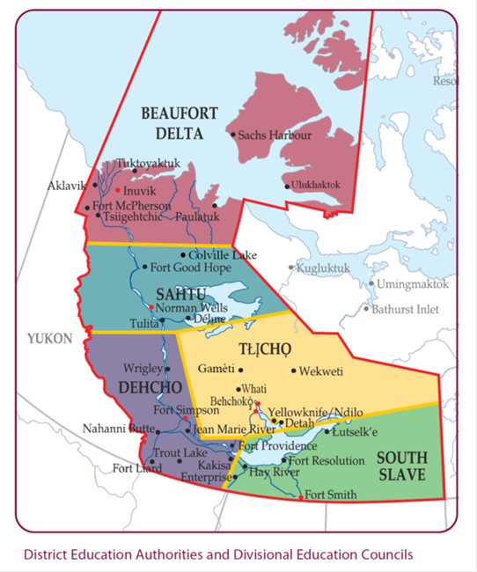

Education System Governance
The Government of the Northwest Territories (GNWT) employs approximately 500 teachers through its six GNWT Divisional Education Councils (DECs). There are two School Boards in Yellowknife who also employ teachers: Yellowknife Catholic Schools (YCS), a public denominational school board, employs over 100 teachers; Yellowknife District Education No. 1 (YK1), a public school board, employs approximately 214 teachers and educational assistants. Ndilo and Dettah Community Schools have their own DEC’s but contract their Board Services through YK1.

Our Schools
There are 49 schools in 33 communities across the Territory:
Range in size from ±600 students to ±4 students
Majority are all grade schools (Junior Kindergarten to grade 12)
10 schools offer French immersion – in Fort Smith, Inuvik and Yellowknife
3 schools offer Aboriginal Language immersion programs at certain grade levels – in Behchoko, Fort Providence and Inuvik
2 schools are French First Language schools – in Yellowknife and Hay River

Our Students
In 2011/12, just under half of NWT students in grades 1-9 were on alternate programs.
33% were recorded as being 1 grade below or accommodated
8% were on Student Support Plans and 2 or more grades below
2% were on Individual Education Plans, indicating significant special needs and an inability to work on curricular standards even with modifications or accommodations

NWT Educational Directives

Section Contents
NWT Ministerial Directive on Inclusive Schooling
Directive Statement
Inclusive Schooling Vision
Classroom Practices/Models/Strategies that Facilitate Inclusion
A Collaborative Model of Inclusive Schooling

Indigenous Language and Culture Based Education
Directive Statement
Indigenizing Education in the NWT
Foundational Documents
Indigenous Language and Culture Programs
Indigenous Language Learning
Supports for New and Beginning Teachers in the NWT

Early Childhood Education

Quality Teaching, Learning and Assessment

Student Assessment, Evaluation, and Reporting (SAER)
Purpose
Definitions
Classroom Assessment Approaches
NWT Systemic Assessment Approaches
Additional Resources

NWT Ministerial Directive on Inclusive Schooling
In accordance with the NWT Ministerial Directive on Inclusive Schooling (2016), education bodies must welcome students within a common learning environment in the community in which the student resides and provide support through School-Based Support Teams to enable teachers to meet the diverse needs of students, including those who experience significant barriers to learning.
The Inclusive Schooling Vision is to ensure access to quality education for all students by effectively meeting the student’s diverse needs in a way that is responsive, accepting, respectful and supportive.
Inclusive schooling in the Northwest Territories:
Recognizes that every student can learn.
Is individualized – educational programs and decisions focus on the individual student’s strengths and needs, and are based upon the student’s best interests.
Ensures access to appropriate learning opportunities by utilizing evidence-based instructional and support strategies to remove barriers to learning.
Enables all students to participate within a common learning environment shared amongst age-peers in the community in which the student resides.
Is delivered within an accessible physical environment where all students and school personnel feel welcome, safe and valued.
Is respectful of student and staff diversity in regards to their race, colour, ancestry, nationality, ethnic origin, place of origin, creed, religion, age, disability, sex, sexual orientation, gender identity, marital status, family status, family affiliation, political belief, political association, social condition and a conviction that is subject to a pardon or record suspension. (NWT Human Rights Act, Section 5 (1) 2014)
Is characterized by collaboration: parents, affected student (where appropriate), school principals, classroom teachers, program support teachers, support assistants, and other professionals collaborate to make decisions related to the educational needs of individual students.
Promotes the involvement of parents/guardians in their child’s education.
Establishes and maintains a professional learning program to ensure that educational staff have the knowledge and skills needed to provide effective instruction to a diverse student population.
Promotes partnerships between schools and their communities, operating effectively through a range of school-wide supports and community programs and services available to all students.
When a student is identified as a struggling learner, it is the teacher’s responsibility to monitor the student’s progress and provide support when necessary. When best instruction practices are not meeting a student’s needs, it is time to consider whether a SSP or IEP may be necessary, in consultation with the School-based Support Team and parents/guardians.
These plans are evolving documents. Teachers, in collaboration with the School-based Support Team, develop, implement and update the learning goals and instructional strategies whenever significant changes or accommodations are required.
Teachers will actively participate within the School-based Support Team, when the team is meeting about a student in their class, to develop or utilize a number of informal to formal assessment strategies across time periods and situations to determine students’ strengths and challenges. These instruction and assessment strategies must change as circumstances require.
All children bring their own unique strengths, experiences and understanding to the classroom. Society is richer when all children are valued. The teacher has the following supports to help plan programs that meet the student needs:
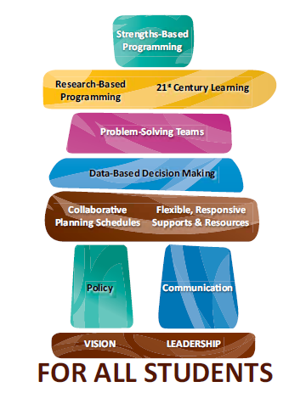
At the school level, program support teachers and student/support assistants
At the board level, board consultants
At the community level, parent and community involvement in education
Time to plan with the school-based team
Professional development in the use of strategies such as multi-level instruction

Everyone benefits from inclusive schooling. Children who may have been excluded in the past, become part of a group and the other learners learn understanding, empathy and tolerance for difference. The greatest obstacle is the way people think. When we shift our thinking from focusing on children‘s problems to recognizing their strengths, we are more apt to see the opportunities inclusive schooling presents. It is critical to identify the children‘s needs, and often that requires specific programs and resources.

CLASSROOM PRACTICES/MODELS/STRATEGIES THAT

FACILITATE INCLUSION

Here are some of the practices, models and strategies that can help schools to facilitate inclusion. Please refer to the Northwest Territories Program Support Guide and other supporting documents for more information.

Universal Design for Learning (UDL)
UDL provides a framework to improve the learning environment for all students. Incorporating UDL principles into the design and development of curriculum and classroom practice - including learning outcomes, activities, assessments, and teaching methods - improves the accessibility of learning for all students.
UDL helps the teacher make instruction more flexible and student-centered. It engages students in the learning process and allows them to make choices in acquiring knowledge and skills, as well in how they demonstrate their learning.

Tiered Levels of Support (i.e.: Response to Intervention model)
This is a multi-tiered approach to the early identification and support of students with learning, social-emotional and behavioral needs that begin with high-quality classroom- wide instruction, universal screening of all students and applying interventions as required.

Differentiated Instruction
Differentiation involves adapting instruction to meet individual needs including differentiating content, process, products, or the learning environment. Differentiation may mean teachers respond to learners in the classroom by adjusting teaching in order to create the best learning experience possible.

Inquiry-Based Learning
This approach to teaching allows student interests, questions, ideas and observations to guide the learning experience. Students engage in evidence-based reasoning, creative problem-solving, and open-ended investigations, often stemming from their environment and/or experiences.

Multiple Intelligences Model
Students learn, remember, perform, and understand in different ways. This model outlines nine types of intelligence and encourages educators to plan for reaching students through the use of multiple modalities.

Cooperative Learning
Students working together in small groups with individual accountability can facilitate better learning outcomes and improve student relationships and the classroom collaborative culture.

Positive Behavioral Interventions & Support (PBIS)
PBIS recognizes that behavior is a form of communication through which students express their needs. Consistent, common expectations that are predictable, explicitly taught, and positively reinforced, enables teachers to focus less on classroom management and more on student instruction.

Self-Regulation (SR)
Self-Regulation is the ability to manage your own energy states, emotions, behaviors and attention, in ways that are socially acceptable and help achieve positive goals, such as maintaining good relationships, learning and maintaining wellbeing (Shanker, 2012). By applying the principles of SR to the classroom, educators can help students by providing adaptations, strategies, routines, tools and lessons that will enable students to become more aware of their energy states and of how to modulate them to attain the best state for learning.

Educator Wellness
Educators must be well in order to care for their students and offer them the best teaching and learning environment. Self-care needs to be a teacher focus, so that they are fully available to their students.

Trauma-Informed Practice
Trauma has an enormous effect on education and health outcomes. The impact of the legacy of Residential Schools in NWT communities cannot be underestimated. Educators must be aware of this, and of other possible traumas affecting students’ lives, in order to help student manage their emotions, behaviors, energy levels and attention in order to be able to do their best learning. Teachers need the support of their School-based Support Team to know how and when to connect a student affected by trauma to a trained professional.

Collaborative Professional Learning and Teaching
Professional learning and capacity building for school and regional/district staff is a foundation necessary for successful implementation of Inclusive Schooling.

A Collaborative Model of Inclusive Schooling
Inclusive Schooling is defined by collaboration; parents, principals, teachers, program support teachers, peers, and other professionals collaborate to make decisions related to the educational needs of individual students.
Collaboration means working together to produce results. In Inclusive Schooling this means using the strengths of the School-based Support Team members to best meet the needs of the students. In a collaborative process, team members are guided by a query from a teacher, and seek to support that teacher in meeting the needs of the students. The team members are invested in the success of the teacher and student and actively seek to provide on-the-ground support. All members in this process are equals at the table, and each member brings their own unique perspective.
Consultation means meeting with individuals, often experts, in order to discuss a situation and seek advice. In Inclusive Schooling, consultation is used, when needed, as a way to get new ideas or strategies to best meet student needs. In a consultation, the experts are not responsible for implementing strategies. They may or may not know the student, the community or the school. In their role, they provide advice and may provide follow up consultation, if desired. It is essential that the School-based Support Team evaluate the advice of experts and implement within the context of their known realities.
Both collaboration and consultation are used in Inclusive Schooling. Collaboration is an essential ongoing practice, whereas consultation only occurs when needed, as determined by the School-based Support Team.
Coaching and modeling are critical components of collaboration within the School-based Support Team. The Program Support Teacher is ideally positioned to best coach a teacher in the development of new skills and model implementation of new strategies. Coaching and modeling both are job-embedded professional development strategies that strengthen Inclusive Schooling.
The following model of Inclusive Schooling service delivery in the NWT outlines roles and responsibilities for effective implementation. A key aspect of this model emphasizes the importance of supporting classroom teachers to effectively deliver challenging and appropriate learning experiences for all students.
Effective learning environments are comprised of many levels of support:
- School-based Supports
- Education System Supports
- Health & Social Services System Support
- Community Supports

School-based Supports
The Directive clearly indicates the central role the classroom teacher plays in meeting the needs of each student in the classroom. The success of the teacher in providing effective instruction to a diverse group of students is dependent on many factors. No matter how skilled and experienced the teacher may be, there will always be new situations and circumstances where the teacher needs additional support.
Several schools in the NWT are in communities with a small population and student enrollment. These schools may have particular challenges. For instance, some may not have a Program Support Teacher. Every effort must be made to meet the needs of small schools in a creative and equitable manner.
The establishment and operation of a School-based Support Team (SBST) in which each participant plays an effective role is essential to the success of an inclusive school and its teachers.
The School-Based Support Team consists of the principal/assistant principal(s), the program support teacher(s), the support assistant(s) (as appropriate) and other staff including counselors, mentors, and others. While these may be the core members in larger schools, actual membership will vary depending on the school and the number of staff members. However, whatever the size of the community or the school, it is critical that collaboration occurs in order to problem solve together and best meet student needs. In very small schools, this might occur through virtual meetings with Regional/District staff or with teachers and administration from another school.
Whatever the circumstance, making the school program work for a diverse student population is not always easy, but it is achievable. It requires a great deal of collaborative effort by staff members to resolve the challenges that inevitably come to the surface in classrooms. Strong and effective collaborative structures that tap into the knowledge, experience and expertise of the educators working in the school/district are the primary building blocks for success.
The primary roles of the SBST members should be to support the classroom teacher through coaching, co-teaching, co-planning and consultation. They should function as a team with a shared vision, a focus on collaboration, collegial support, joint problem-solving and promising practices and strategies that result in teacher and student success.
The following provides a discussion of the role of each of the key team players.

A.1. Principal (and Assistant Principal)
The Principal provides needed leadership for the effective functioning of the school-based team by setting conditions (ex. creative timetabling) so the program support teacher (PST) can work effectively with classroom teachers, and by working closely with the PST to ensure all staff have the opportunity to collaborate and problem solve within the school-based collaborative team model.
The principal must also ensure that teachers have access to relevant professional development opportunities related to inclusive practices, and will monitor and follow the accountability framework mandated in the Directive. Facilitating an inclusive culture in the school and advocating for community and district support for programs and services to meet teacher and student needs is a critical responsibility of the principal.

A.2. Program Support Teacher
The Program Support Teacher (PST) provides leadership to the school-based team to ensure effective inclusive practice while working collaboratively with the principal and other team members. The role of the PST in an inclusive school must be focused on supporting and working directly with classroom teachers. The PST is preferably an experienced and knowledgeable teacher, who works well with colleagues, and who can provide a range of supports to help build teacher capacity for utilizing effective and appropriate pedagogical strategies.
A Program Support Teacher contributes to the education of students with diverse needs by serving as a colleague, role model and coach for teachers with regards to inclusive instructional practices. The PST works with all members of the school team to ensure consistency of understanding and delivery, and provide support where needed.
The PST maintains a working knowledge of NWT curriculum, related research, exceptionalities, and inclusive instructional practices (ex. classroom lesson plans/units, Universal Design for Learning or UDL, and assessment practices) in order to collaborate with the classroom teacher who holds the subject matter expertise.
In carrying out this role, the PST will focus on activities and functions that directly support classroom teachers to meet the needs of their students. The Directive provides guidance in this by setting out PST priority time-use targets:
a minimum of 60% of the PST’s time should be devoted to teacher support activities
no more than 25% of the PST’s time should be spend working directly with students (commonly Tier 3 students – those with more complex needs)
a maximum of 15% of the time used for other functions

A.3. Support Assistants
Support Assistants (SA) play a valuable role in assisting teachers to meet the needs of students to successfully access curriculum and services.
A Support Assistant, under the direct supervision of a qualified teacher assists with:
carrying out instructional and behavioural plans (SSPs and IEPs);
classroom management and student supervision; and
providing instructional and other supports to students

The duties of the SA may be many and varied, depending on the particular situation; they do not, however, replace those professional responsibilities of the teacher(s) nor are they limited to the needs of any one student. While the primary responsibility of SAs may be to work with students who have educational challenges, they are also a resource to the whole class. Support Assistants are used to provide that extra help that only an additional adult in the classroom can provide to a teacher.

Support Assistant tasks include (but are not limited to) the following:
Contributing to the education of students in inclusive schools and classrooms by implementing supplemental small-group and individual instruction;
Engaging in instructional monitoring of student work (ex. independent or small-group work) identified and planned by teachers and PSTs;
Preparing instructional materials for use by student(s) under the direction of the teacher (ex. materials for braille, manipulatives for kinaesthetic learners, etc.); and
Collecting formative assessment data on student performance and progress, and/or behaviour observation data, based on collection systems designed by teachers or PSTs;
Facilitating peer interactions based on guidance from the teacher and PST. They invite students to help each other. They may also engage in non-instructional tasks (ex. group supervision such as on the playground, during bus boarding, in the cafeteria, and/or on field trips) identified by teachers and the PST;
Applying current promising practices and strategies learned through professional development and school-based in-service/workshops;
Delivering programs prepared by teachers, PSTs and/or other professionals (ex. speech and language pathologists, occupational therapists) such as life skills training; and
Providing needed care in order to access the education system (ex. toileting, feeding, safety supervision, etc.)

A.4. Other School-based Staff Members
Some schools have additional staff members who play a role in supporting instruction. Their roles vary and depend on the mandate provided by the funding that makes the position possible. Some of the positions found in schools in the NWT include the following:
Counsellor
Art Therapist
Literacy Support Teachers/Coaches
Numeracy Support Teachers/Coaches
Other support staff

These staff members provide support to the teacher or the student using appropriate strategies as a member of the School-based Support Team.

A.5. Classroom Teacher
While the School-based Support Team and its individual members provide assistance to classroom teachers, it is the teacher that connects with the student day-to-day in the classroom and provides the learning opportunities that result in student success. The task of the teacher in meeting 21st Century learning outcomes with students is not without its challenges. Collaboration and teamwork are vital to achieve optimal results for students.
Teachers will contribute to the education of all students in inclusive schools and classrooms, and support the learning needs of all students by:
Collaborating with school-based staff to create opportunities that facilitate the valued membership of all students in the common learning environment (ex. instructional planning, classroom set-up, purposeful student groupings, and meaningful participation);
Knowing the first priority to be student relationship building, followed by familiarity with the student’s learning characteristics, performance levels, and personalized learning outcomes;
Applying formative assessment, universal design for learning, differentiation, universal strategies (ex. self-regulation) and other learner-centred activities, so that students can pursue and achieve curricular-based learning goals;
Supervising and directing Support Assistants to maximize their effectiveness in supporting students; and
Engaging in coaching and co-teaching opportunities with Program Support Teachers and other colleagues to accommodate all students within an inclusive environment.

Education System Supports
The Education System external to the individual school plays an important role in supporting the teacher and school staff in meeting students’ needs. Its role ranges from setting policy and sourcing funding mechanisms, to providing practical assistance for resolving unfamiliar and complicated situations, as well as providing opportunities for training and capacity building.
These supports include the Regional Inclusive Schooling Coordinator (RISC), The Superintendent and the Department of Education, Culture and Employment (ECE) staff.

Health & Social Services System Supports
The involvement and support of professionals working in the Health & Social Services systems can be critical to school success for some students. Some professionals may be involved with schools on a systemic basis and others on a case-by-case basis. ECE is committed to working with the Department of Health and Social Services to facilitate integration of education, health and social services delivery to support student success in the classroom.

Health and Social Services system supports may include:

C.1. Health and Social Services Authority (HSSA) Professional Services:
Audiology
Mental Health Counselling
Occupational Therapy
Physician Specialists (Paediatrics, Psychiatry)
Physiotherapy
Primary care medical services (physician, nurse practitioner or community health nurse)
Social work
Speech-Language Pathology

C.2. Health and Social Services Authority (HSSA) Diagnostic Services teams:
Stanton Territorial Health Authority (STHA) Child Development Team (CDT)  CDT Diagnostic Assessment Clinic  Child Development Team (CDT) Intervention Team  Other members of the Stanton Child Development Team include:  The child and family in question  Pediatrician  Speech Language Pathologist  Occupational Therapist  Physiotherapist  Audiologist  Education professionals  Child Development Team Coordinator | STHA FASD Family and Community Support Program  FASD Diagnostic Clinic  Family and Community Support  Other members of the FASD Diagnostic Team include:  Pediatrician  Psychologist  Speech Language Pathologist  Occupational Therapist  Audiologist  Social Worker  Family Liaison  Child Development Team Coordinator

D. Community Supports

D.2. Indigenous Government and Local Leadership Band Council Partner Programs
Local community leadership plays a key role in supporting education programs in individual communities in all regions. Each community offers unique programs and supports to help serve their students and support their schools.

D.2. Possible Community Programs
Language and Cultural Programs
Student tutoring programs
School supply programs
Recreation programs
Counselling services
Addiction services

D.3. Community and National Agencies
Some communities in the NWT benefit from organizations that work closely with educators and families. These include, but are not limited to, agencies such as:
NWT Disabilities Council
NWT Literacy Council
Centre for Northern Families
Yellowknife Association for Community Living (YACL)
Canadian National Institute for the Blind (CNIB)
Learning Disabilities Association
YWCA – NT (www.ywcanwt.ca)
Human Rights Commission (www.nwthumanrights.ca)
Assistance Dogs in Canada (http://www.dogguides.com)

There are also organizations and agencies that provide information helpful to Inclusive Schooling at the national level. These include, but are not limited to, agencies such as:
Inclusive Education Canada (IEC – www.inclusiveeducation.ca )
Canadian Research Centre on Inclusive Education - Western University (http://www.inclusiveeducationresearch.ca )
People First of Canada (www.peoplefirstofcanada.ca)
Canadian Association for Community Living (CACL - http://www.cacl.ca)
Council of Canadians with Disabilities (www.ccdonline.ca)
Canadian Hard of Hearing Association (www.chha.ca)
Active Living Alliance (www.ala.ca)
Disability Tax Credit (www.cra.gc.ca)
Canadian National Institute for the Blind-Alberta/NWT (www.cnib.ca/en/alberta)
MS Society Alberta/NWT (www.mssociety.ca/alberta)

Assistance Dogs in Canada (http://www.dogguides.com)
Autism Society Canada (www.autismsocietycanada.ca)
PREP Program (Pride, Respect, Empowerment, Progress) – Down Syndrome (http://www.prepprog.org/)

D.4. Parents & Families
As their child’s first teachers, parents establish the foundation for lifelong learning. They are responsible for their child’s early education, including the acquisition of language, culture and social skills.
While all students benefit from the involvement of their parents in schooling, parental involvement is even more crucial for those students with learning differences. Parents/guardians can contribute to education within inclusive schools and classrooms by developing an understanding of their child’s strengths, interests, and needs. It is helpful in guiding program planning when parents/guardians participate in planning activities including the Making Action Plans (MAPs) and Circles of Friends processes.
Families know so much about their children that can be useful to educators in their planning. Communicating key information to the School-based Support Team and/or teacher about learning preferences, health, mental health, culture and community issues that contribute to educational planning priorities for children is essential to their success.
In collaboration with school staff, family members can identify and/or select a set of learning priorities for the semester/term, and can help to identify supports necessary for student success. As families are forever, it is in everyone’s best interest that they play a prominent role in long-range educational and transition planning.

Indigenous Language and Culture Based Learning
The NWT endeavors to ensure that all schools provide students and educators with learning environments that foster and respect the values, worldviews, and languages of the community in which they live and work. The NWT Education Act ensures the delivery of culture-based school programs as part of the regular education program, as well as the provision of Indigenous language learning opportunities.
Culture-based education is education that reflects, validates and promotes the cultures and languages of the Indigenous peoples of the NWT. It is education that honours all forms of traditional knowledge, ways of knowing and worldviews. Rather than teaching aspects of Indigenous culture, the NWT seeks to ground all teaching and learning in culture, community and place. In other words, the goal is to teach through culture, not just about culture.
This section provides an understanding of:

Indigenizing Education in the NWT;

Indigenous Language and Culture Foundational Documents;

Indigenous Language and Culture Programs;

Indigenous Language Learning Programs; and

Additional Supports for New and Beginning Teachers in the NWT.

Indigenizing Education in the NWT
Indigenizing education refers to a pedagogical shift that encourages the inclusion of Indigenous content, understandings, and processes into all aspects of the formal education system. Indigenizing education requires viewing, developing, and delivering education through the lens of the Indigenous culture tailored to each individual community.
To accomplish this, NWT teachers must center Indigenous ways and practices in NWT Schools, looking to community Elders, cultural knowledge holders, and leaders for guidance.

NWT Schools are expected to:
Support culture-based educational experiences for all students;
Reflect the local culture and environment throughout the school;
Actively participate in the Elders in School program;
Provide Indigenous language programming; and
Provide teachers with professional development, which aims to orient them to the community‘s culture.

NWT Teachers are encouraged to:
Meet the community and take part in community events, celebrations, and ceremonies;
Use local materials and community human resources, including Elders and community leaders, in lesson planning and delivery of instruction;
Open lines of communication with families through introductions, as soon as possible;
Stay in contact with parents throughout the year regarding student successes and challenges;
Incorporate the community culture into classrooms and lessons;
Learn as much of the local language as possible, and use it often in lessons, classrooms and school; and
Take the time to learn about the community, and community members, to better understand:
the unique history of the community and the NWT;
the current political, cultural and socio-economic environment;
the local history and legacy of the residential school system;
historical and contemporary Elders and heroes;
regional land claims;
political and social structures; and
community protocols and ceremonies.

Foundational Documents
Education in the North is guided by foundational documents, including the NWT Education Act and Regulations, and the Education Renewal Framework: Directions for Change, as well as by Ministerial Directives and Curricula.
In terms of Indigenous Language and Culture, there is one Directive and two additional foundational curricula that are expected to be followed in all NWT schools:
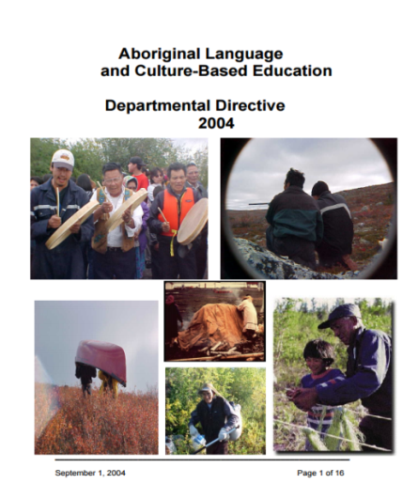
Departmental Directive on Aboriginal Language and Culture-Based Education
Dene Kede (For schools in the Dene Nations: Gwich’in, Sahtú, Dehcho, Tłı̨chǫ and Akaitcho)
Inuuqatigiit (For schools in the Inuvialuit Settlement Region)
Departmental Directive on Indigenous Language and Culture-Based Education
In 2004, a Departmental Directive for Indigenous Language and Culture-Based Education (ALCBE) was developed. All school administrators and teachers are expected to read and follow this Directive.

Guiding Principles of the Directive:
Parents, grandparents, family and community members are a child’s first teachers;
Indigenous children are more successful when the school affirms their culture;
The land is a place of learning and is an important part of the successful learning of Indigenous languages and cultures; and
Communities have much to offer the education system.

Key Cultural Experiences:
In accordance with the Directive, schools are directed to offer key cultural experiences to students, as part of culture-based education. These activities explore the languages, cultures, histories, activities, skills, knowledge, traditions and values of Indigenous peoples of the NWT. Key cultural experiences must be culturally authentic, realistic, and natural, and are best done in a traditional setting (i.e.: on-the-land), using as much Indigenous language as possible.
Some examples of key cultural experiences are:
Attending cultural trips on-the-land, such as Indigenous language camps or hunts;
Learning traditional skills, such as sewing, snowshoe making, or drum making;
Participating in cultural activities, such as drum dances or feasts;
Playing traditional games, such as drumming, chanting, or storytelling; and
Assisting with traditional food gathering and preparation, such as hunting, trapping, berry picking, making bannock, and fishing.

Indigenous Foundational Curricula: Dene Kede and Inuuqatigiit
To respect the NWT First Peoples’ languages, worldviews, and land, two foundational curricula have been developed: Dene Kede and Inuuqatigiit. All school administrators and teachers are expected to bring forward the Indigenous worldview of their communities in all of their teachings, using the curricula appropriate to their school and community, dependent on the region.
These curricula are informed by a number of philosophical perspectives or worldviews that shape understanding of the Dene and Inuit core concepts, as well as the tradition of lifelong learning. Dene Kede and Inuuqatigiit both promote meaningful language use, as language is interwoven with culture and heritage through meaningful experiences.

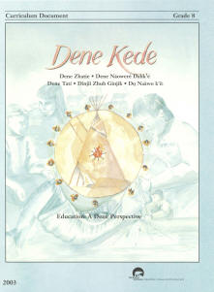
Dene Kede
Dene Kede encompasses the language, culture and the way in which five Dene nations view the world: Gwich’in, Sahtú, Dehcho, Tłı̨chǫ, and Akaitcho.
Kindergarten to Grade 6 takes a thematic approach teaching the four fundamental relationships of respect central to the Dene perspective:
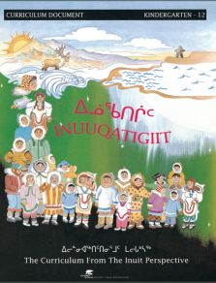
Grade 7 to 9 follows instructional modules to present students with the experiences, knowledge, skills and attitudes, which will guide them toward becoming capable people.

Inuuqatigiit
Inuuqatigiit is a foundational curriculum document developed by Inuit and Inuvialuit educators and Elders from the eastern and western Canadian Arctic, and grounded in the belief of the Elders that education must be community-based.
The curriculum is based on the Inuit belief that learning is a process that takes many different forms, and is intended to develop students’ pride of identity and language through five main goals:

Other Subject Curricula
ECE has taken the approach of developing and writing all NWT curricula from a northern perspective to reflect the health and vitality of many cultures in a rapidly changing environment. They incorporate traditional knowledge, use Northern geographic examples and are supported by culturally appropriate learning materials and pedagogy. They provide an opportunity for Northern students to understand and experience each other‘s perspectives.
Additional information on all NWT Foundational Documents, Ministerial Directives and Curricula can be found on the ECE website: http://www.ece.gov.nt.ca

Indigenous Language and Culture Programs
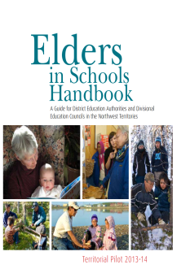
The NWT has developed two territory-wide programs aimed at Indigenizing education in NWT Schools. Each of these programs were first piloted as a part of the 2011 Aboriginal Student Achievement Education Plan and have since become mandated programs in all NWT schools.

Elders in Schools
The NWT honours the vital role that Elders play to promote the integration of languages and culture in school programming. Elders have valuable skills and knowledge that they can share with students and staff.
The Elders in Schools program was developed to ensure that Elder involvement in education is increased and strengthened. The broad program objective is for students to learn about northern heritage and place through authentic experiences led by Elders. These learning experiences help students shape their identity as people of the NWT. The Elders in Schools Handbook lays out protocols, steps and considerations to be followed when working with Elders in schools and also shares some promising practices.

Cultural Orientation Days
All NWTTA members receive two days of culturally appropriate orientation to the region, community, or territory. The experience helps to ensure teachers understand the unique culture, history, traditions, and values of the Indigenous peoples in the NWT, and in particular of the people in the region and community in which they live and work.
Topics that may be covered during the orientation are:

History of formal education in the NWT, including the residential schools experience;
Traditional ways of learning, being, and teaching;
Legends and stories of the community and region;
Basic conversation in the community/regional Indigenous language;
Key cultural experiences on-the-land and within the community;
Protocols and ceremonies of the community and culture;
Culture-based education and incorporating Dene Kede or Inuuqatigiit; and
Significant places and people in the community.
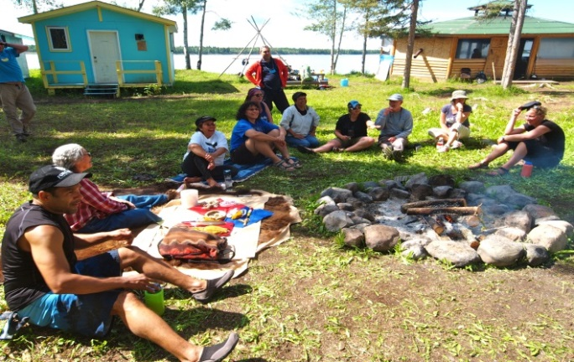
Providing teachers and school administrators with the opportunity to learn about the community where they live and work can help develop positive relationships between teachers and their students and parents, as well as with the community at large.

Indigenous Language Learning
There have been many significant changes to the ways Indigenous people lived in the past. These changes include experiences, such as residential schooling, living in a static community setting, and participating in a non-traditional work force. With all these changes, one of the most significant impacts has been the steady decline of Indigenous language use in the NWT.
Languages are the foundation on which cultures are created. Languages are integral to healthy communities, individual self-esteem and the growth and development of people. Through the use of languages, people express their unique worldview, value and self-worth. Languages help people define relationships and collect and share knowledge to solve the challenges they face.
Statistics show that there is a rapid decline in the use of all Indigenous languages, particularly amongst the speakers of Indigenous languages in the NWT. A very low percentage of children are now learning the languages naturally at home. Most fluent speakers of the languages are age 50 years and over. For these reason, ECE, education bodies, and schools have developed and are continuing to develop supports that integrate Indigenous Language and Culture programs in the NWT schools.

Official Languages
The NWT is the only jurisdiction in Canada that names nine (9) official Indigenous languages alongside English and French through its Official Languages Act. The Act recognizes that many languages are spoken and used by people of the NWT, and is committed to the preservation, development and enhancement of Aboriginal languages. The nine (9) Indigenous languages belong to three different language families: Dene, Inuit and Algonquian/Cree.

A Whole School Approach to Model Language Learning
All staff members have a role in helping to maintain and revitalize the language of the community, regardless of their own ability to speak the language fluently. When teachers try to learn an Indigenous language in the school and community, it shows that there is value in the language. When teachers have troubles remembering words or proper pronunciations, it can model the learning process for students helping them to feel safe to try as well.
Some suggestions on how teachers can incorporate Indigenous languages in the school include:
Attending and participating in Indigenous language classes with students;
Greeting students each morning in the language of the community;
Teaching a school prayer and O Canada in the Indigenous language;
Encouraging Indigenous language use throughout the whole school, as often as possible;
Integrating Indigenous language into other subject matters; and
Using Indigenous language signage or labeling throughout classrooms and the school.

Indigenous Language Learning Classes
The NWT Education Act allows the ability to provide Indigenous language learning through first language instruction, immersion and second language instruction. The level of language programming is largely dependent on sufficient demand, availability of qualified teachers who are fluent speakers and availability of sufficient and suitable program materials.
If English is the language of instruction, another NWT Official Language must also be taught as part of the education program. Currently there are no NWT schools offering first language instruction in an Indigenous Language. In most NWT schools, English is the main language of instruction and an Indigenous language or French is taught as a second language through a second language, ‘core language’ approach, or immersion.

Immersion Language Learning
In an immersion language approach, all regular instruction is taught in an Indigenous language. Indigenous language immersion classes are in place in three NWT communities: Behchokǫ̀ (K-2), Inuvik (K) and Fort Providence (K-3).
Although immersion programming is proven to be the most effective way for students to learn a second language, it is very difficult to implement as it is dependent on the availability of qualified teachers who are fluent speakers, and on the access to sufficient and suitable program materials.

Core Language Learning
In a core language approach, students attend language classes throughout the week in one of the official languages for a minimum of 90 hours per year from grades one through nine. The majority of NWT schools offer this type of programming. Additional Indigenous language courses for senior secondary students, grades 10-12, are also available in some schools.

Our Languages Curriculum
Our Languages is a draft ECE curriculum for Indigenous Language Instruction in JK-12 core Indigenous language classes throughout the NWT. The draft curriculum is aligned with the two foundational documents, Dene Kede and Inuuqatigiit, and focuses on student attainment of five language learning levels: Emergent, Beginner, Intermediate, Advanced, and Proficient.
Our Languages draft curriculum is scheduled for a small scale pilot in September 2017 with full scale pilot in 2018 and territorial implementation in September 2019.

Supports for New and Beginning Teachers in the NWT

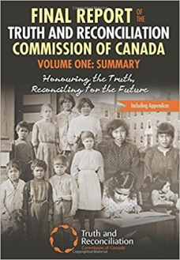
Residential Schools Training
All JK-12 teachers across the territory will be offered the opportunity to complete training on the history and legacy of residential schools in the Northwest Territories. This training helps teachers understand the effects of the residential school system on the cultures, livelihood, languages and families of the students they teach and the communities they are living and working in. This training will be offered to all new teachers coming to the NWT.
NWT teachers are encouraged to read and learn more about the history and legacy of residential schools as they orient themselves to their schools and communities. Most specifically, teachers are encouraged to read the Final Report of the Truth and Reconciliation Commission of Canada, Volume One: Summary: Honouring the Truth, Reconciling for the Future.
The Summary report can be found at https://goo.gl/mwq0Iy and the Calls to Action can be found at https://goo.gl/A9Nefh.

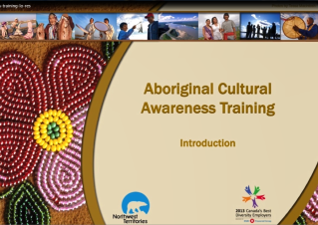
Indigenous Cultural Awareness Training
The Department of Human Resources offers an online Indigenous Cultural Awareness Training program, which provides GNWT employees with information and context about the NWT First Peoples, communities, and regions. Its content is Northern specific and provides historical information on government and Indigenous relationships.
This training increases understanding about Indigenous culture, enhances awareness, and promotes a spirit of inclusion. This training also reaffirms Indigenous values and partnerships as a key foundation of the GNWT based on respect, recognition and responsibility. The GNWT Cultural Awareness Training is comprised of an introduction and four modules.
Access Indigenous Cultural Awareness Training here: http://www.hr.gov.nt.ca/resources/aboriginal-cultural-awareness-training

Teaching and Learning Centres
Teaching and Learning Centres (TLCs) offer Indigenous language support to teachers and language instructors. The mandate of TLCs is the preservation and enhancement of Indigenous language and culture through the promotion of literacy and the integration of local language and culture in school programs. Their goal is to support the implementation of culture-based education by producing books and other materials, and by supporting teachers. All TLCs share this mandate with some variation in structure, reflecting conditions within individual region; some are actual centres and others are run through schools, band offices, or school board offices.
The roles and responsibilities of TLCs have become more diverse over time. In the early days, the major focus was on the development and publication of books and teaching materials for use in classrooms. With the development of Dene Kede and Inuuqatigiit, this role has shifted somewhat to the implementation of curricula, a role that requires TLC staff to work more closely with all other school staff members through workshops and other professional activities.

French Language Programs
French is one of the eleven official languages of the NWT. Six communities in the NWT offer French through a range of programs and courses: French second language courses (Core French), early immersion programs, intensive and post-intensive programs. French first language education is also available in some communities. In total, 2,726 students participated in French programs in 2014/15, representing 33% of all students enrolled in Kindergarten to Grade 12 schools in the NWT.
Of a total of 2,512 students learning French as a second language in elementary and secondary schools in 2014/15, the majority (63%) are taking Core French courses. This form of second language delivery is available in Fort Smith, Hay River, Fort Simpson, Yellowknife and Norman Wells. In these communities, students from Grade 1 to Grade 12 are given a choice in their study of a second language. They can either choose to learn the Aboriginal language of their community or French. On average, 90 hours of instructional time is devoted to this program.
Another 31% of students who are learning French as a second language were enrolled in immersion programs. Early immersion starts in Kindergarten or Grade 1 and can continue through Grade 12. In 2014/15, there were 783 students enrolled in French immersion programs in Yellowknife, Inuvik and Fort Smith. On average, students spend about 85% of their time learning in French, but this can vary from as much as 100% in Kindergarten to 50% in Grades 10 to 12.
Another alternative for students who are learning French as a second language is the intensive and post-intensive French program. In 2014/15, 156 students in Yellowknife and Hay River were involved in this delivery model of learning a second language. For one semester in Grade 6, the students spend approximately 75% of their day learning French. During the following semester of Grade 6, they study French 25% of their day. In the post-intensive years, students spend less time on the study of French: 20% of the day in Grades 7 through 9 and 12.5% in Grades 10 to 12.
In 2014/2015, nearly 215 students were enrolled in French first language (FFL) education. In this program, the language of instruction for all subjects is French (except for English Language Arts which start in Grade 4). Student eligibility for this program is based on the right of French first language instruction as outlined in Section 23 of the Canadian Charter of Rights and Freedoms. This program is offered in two Francophone schools which are located in Yellowknife and Hay River.
Teacher recruitment and retention plays a critical role in the delivery of French language and cultural programs. There is a high demand for French first and second language teachers throughout Canada making it challenging to recruit teachers to the NWT.

Early Childhood Education
The early years of a child’s life are critical to creating a foundation for healthy development and learning. These early years provide an essential opportunity to nurture and support the healthy, social, emotional, cognitive and physical development of young children.
The Department of Education, Culture and Employment (ECE) continues to work in collaboration with the Department of Health and Social Services (HSS) to implement the Framework for Early Childhood development: Right from the Start and subsequent Action Plans. The Framework was released in 2013 and guides the Government of the Northwest Territories’ actions over a ten year period to improve the development of all children aged 0-5. This collaborative work supports children and families using an interdisciplinary approach so that all children, including those who need support, reach their full potential.
Within this Framework, the Department of ECE is continuing to advance work that supports children, families and communities by providing access to high quality early education programs, including:
implementing junior kindergarten for four year old children in all NWT communities;
building an action plan for universal day care within the NWT;
continuing work to increase the number of quality early childhood development professionals in licensed programs;
developing an early learning framework for children ages 0-3 that reflects the cultures of the NWT;
improving the quality of licensed early childhood education and care programs through early childhood environment rating scale (ECERS) in all licensed early childhood programs; and
implementation of the Early Childhood Intervention Program (ECIP) funding to assist with meeting the needs of children who are vulnerable, at-risk and/or those with specific needs.

The Early Development Instrument (EDI) is a significant component of the Right from the Start Framework and Action Plans. Developed by the Offord Centre for Child Studies at McMaster University, the EDI is a checklist that measures children’s developmental health by asking questions about five areas of early development. Since 2012, this tool is completed annually by NWT junior kindergarten and kindergarten teachers.
EDI does not diagnose individual children. Rather, the EDI provides a population-based snapshot of the learning readiness of groups of four and five year old children.
Documents related to Early Childhood can be found at: https://www.ece.gov.nt.ca/en/services/early-childhood-development/documents-forms-and-resources

Quality Teaching and Learning

Creating Teaching Materials
The Department of Education, Culture and Employment, along with many partners in Education including the District Education Councils, the NWT Literacy Council and many individuals, have created a wide variety of books and other teaching resources. A list of ECE materials is available in the resource section of this package. However, you will also find many other resources in other places and your searching will reveal that a wide variety of Northern resources are available to support the goals of your classroom.
You will find it useful to:
Spend some time on the Prince of Wales Northern Heritage Centre website at www.pwnhc.ca. The site has much to offer including edukits for loan, the NWT history timeline, archival photos, searchable data bases with information on people from every community in the NWT, photo collections and much more.
Search the Department of Environment and Natural Resources (ENR) website. ENR has developed many resources for schools including information on most of the North’s plants and animals including range maps, recycling details, bear safety, climate change and conservation planning including beautiful resources on each of the protected areas within the NWT. Some of these resources are also available in the official languages.
Contact the NWT Literacy Council. They have incredible resources for math literacy, language literacy and much has been produced in the languages. They have a catalogue of books and videos as well as resources to help support people who want to produce their own resources.
Contact your District Education Councils for the lists of resources produced at the local and regional level. In some areas hundreds of books have been written and many Elders have been recorded.
Investigate resources from Aboriginal governments and organizations have also created resources. Check out the Gwich’in Social and Cultural Institute website or the Inuvialuit time line or the Tłı̨̨̨̨̨chǫ history timeline.
In our digital age, educators can also create learning products in online spaces that are shareable, linkable, and embeddable. Some ideas for creation include:
Screen recordings of learning experiences created by students with teacher guidance, and shared in protected spaces such as video sharing sites, wikispaces, simple blogs, etc.
Images of local landmarks, cultural events, etc. saved in online photo sharing site with some rights reserved sharing licenses (e.g. creative commons licenses)
Collaboratively develop Wikipedia articles about relevant municipal, cultural, geographic, or historical topics
Collaboratively create a book with an online bookmaking application about a local interest or experience using shared images; sell the book online using the same application; make it available in the local school and community library
Students can also create resources in the form of book making projects. Using readily available materials, their books become a source of pride which can be placed in the library for others to sign out.
One of the best resources are the people of this land. Parents, community members and local artists may also contribute to the collection of teaching resources. People who are knowledgeable in particular areas of the curriculum may be invited to share their knowledge. You can ask to videotape their presentations for future use. When inviting Elders into the classroom, it is very important to find out about the community protocol and the appropriate remuneration before proceeding.

Student Assessment, Evaluation, and Reporting (SAER)
Student Assessment, Evaluation, and Reporting in the Northwest Territories
It is essential that all teachers in the Northwest Territories clearly understand the integral role of assessment in the teaching and learning process, and that student progress be consistently evaluated and reported in relation to NWT curricular outcomes.
Currently, the Department of Education, Culture and Employment (ECE) provides two reference documents to guide student assessment, evaluation, and reporting in NWT schools. These two documents are:
Educating All Our Children: Departmental Directive on Student Assessment, Evaluation and Reporting (2010)
Educating All Our Children: Procedures, Roles and Responsibilities for Student Assessment, Evaluation and Reporting (2011-2012)
The Northwest Territories promotes a policy of inclusive schooling for all learners and uses differentiation of instruction based on assessment information to plan for each student‘s learning progress and goals. This assessment process complements a culturally defined model of inclusive education where the goal of assessment is not diagnosed difference but rather an opportunity to creatively enhance learning through adapted instruction that facilitates individual success. (Philpot, Nesbit, Cahill & Jeffrey. (2004) Cultural Diversity and Education: Interface Issues. Memorial University, Newfoundland. p77)
Through Education Renewal, ECE has committed to ensuring that assessment approaches are comprehensive, growth oriented, and individualized. This commitment involves the provision of tools and supports that seek to enhance classroom assessment practice, encouraging and extending existing teacher collaboration, and working to increase consistency throughout the NWT.

Definitions (As defined in the Directive)
Assessment is the process of collecting information on student achievement and performance that includes a variety of assessment tasks designed to monitor and improve student learning.
Evaluation is the process of making judgments and decisions, based on interpretation of the evidence gathered through assessment, as to what extent students have attained the prescribed outcomes and standards in the course curriculum and identifying what knowledge and skills still need to be learned. Evaluation also involves the making of decisions about the quality, value or work of a response for the purpose of providing descriptive feedback (formative) and marks (summative).
Reporting is the process of summarizing and clearly communicating student progress on curricular outcomes to various client groups, including students, parents, administrators and the Department. Reporting also includes the recording of student data into the student record for each student and submitting data requested by the department.

Classroom Based Assessment
Assessment activities are based on curricular outcomes and may be used to serve a variety of purposes, including:
Assessment for Learning (Formative):
Provides students and their parents/guardians ongoing feedback on a student‘s progress;
Provides information to better differentiate future learning experiences which build on the student‘s strengths.
Assessment of Learning (Summative):
Provides information that can be used to evaluate and confirm student achievement in relation to learning outcomes;
Provides information that can be used to understand the effectiveness of instruction in order to improve student learning.
Assessment as Learning
A power assessment process that focuses upon the role of the student in the learning process;
Occurs when students monitor their own learning and use feedback to make changes in what they understand.

Diagnostic Assessment
To diagnose individual student strengths and needs;
To collaborate with others to improve the student‘s learning;
And, if necessary, to develop and implement a plan of intervention for the student.

Classroom Assessment Approaches
Students may show their learning in many different ways, so teachers in the NWT are encouraged to use a variety of assessment tasks in their classrooms. Choosing an appropriate method of assessment largely depends upon the curricular learning outcome(s) being assessed, why the learning is being assessed, and how the information it provides is intended to be used.
Informed professional judgment is central to effective classroom assessment. To support NWT teachers as they make decisions about their approach to classroom assessment, ECE recommends teachers refer to Rethinking Classroom Assessment with Purpose in Mind (2006), which was developed by the Western and Northern Canadian Protocol (WNCP).
Although not exhaustive, the following tables provide some examples of methods and tools that teachers can choose in their classrooms.
Assessment For Learning
Method/Tool | Description
Effective Feedback | Teacher provided feedback on student learning should be timely, growth oriented, specific to the learning task, and clear.
Questioning | Strategic, focused, and probing questioning to monitor understanding.
Observation | Systematic observations of students as they process ideas.
Learning conversations | Investigative discussions with students about their understanding and conclusions.
Quizzes and Tests | Opportunities for students to demonstrate their learning during a teaching unit in order to assess student readiness about moving onto another activity or concept.
Simulations | Simulated or role-playing tasks that encourage students to show connections that they are making among concepts that they are learning.
Graphic Organizers (KWL, Placemats, etc.) | Graphic organizers encourage student to organize what they know, think, and understand while assisting them in considering what they want to learn and understand.
Exit slips | Students write a response to a specific prompt before they leave a lesson, providing teachers with information about what is and is not clear about student understanding.
Assessment As Learning
Method/Tool |  | Description
Self-assessment |  | Process in which students reflect on their own performance and use defined criteria for determining the status of their learning. (ex. Journals or learning logs).
Using Rubrics with students |  | Co-construction of rubric criteria, allowing students the opportunity to deeply consider what the expectations of the learning are.
Using exemplars with students |  | Process Exemplars – to provide students with information about the thinking process that leads to understanding.  Writing Continuums - Providing student with a number of different samples of writing along a continuum at different developmental levels.
Peer assessment and feedback |  | Process in which students reflect on the performance of their peers and use defined criteria for determining the status of their peers’ learning.
Checklists |  | Descriptions of criteria to consider in understanding students’ learning.
Assessment Of Learning
Method/Tool |  |  | Description
Quizzes, Tests, and Examinations |  |  | Opportunities for students to demonstrate their learning at the end of a lesson, unit, course for the purpose of reporting grades.
Standardized Tests |  |  | Standardized summative assessments can provide useful information about student learning. Some examples in use in the NWT are: Alberta Achievement Tests, Alberta Diploma Examinations, Canadian Achievement Tests (CAT-4), etc.
Projects and student-led inquiry |  |  | Opportunities for students to show connections in their learning through investigation and production of reports and artifacts. (Can also be formative).
Demonstrations and presentations |  |  | Opportunities for students to show their learning in oral and media performances and exhibitions.
Rich assessment tasks |  |  | Complex tasks that encourage students to show connections that they are making among concepts they are learning. Rich assessment tasks address a range of outcomes in one task, connect naturally to what is being taught, are deeply engaging for students, and connect deeply to student inquiry pedagogical approaches.

Diagnostic Assessment
Method/Tool | Description
Fountas and Pinnell Benchmark Assessment System | An externally developed tool designed to determine student’s independent and instructional reading levels.
Basic Reading Inventory (Jerry Johns) | An externally developed tool that helps teachers assess student sight word recognition, comprehension, reading rate, and listening levels.
Teacher Rating of Oral Language and Literacy (TROLL) | An externally developed tool used to assess students oral language, reading, and writing skills.

NWT Systemic Assessment Approaches
Systemic assessments serve different purposes from those of classroom assessments. They supply information about the effectiveness of education systems at the level of the school, district, division, and territory. The NWT is involved in three systemic assessments on an annual basis: Functional Grade Levels, Alberta Achievement Tests, and Alberta Diploma Examinations.
Functional Grade Levels (FGLs) are the grade level of curricular outcomes a student worked at for the majority of the school year. These are reported by teachers for all Grade 1 to 9 students in Language Arts and Mathematics. FGLs are reported in May each year.
Alberta Achievement Tests (AATs) are Alberta developed standardized tests administered to students in Grade 6 and Grade 9. In the NWT AATs are only written in Language Arts and Mathematics.
Alberta Diploma Exams are Alberta developed standardized tests that are administered for Diploma level courses in grade 12. The Diploma Exam makes up 30% of a student’s final mark in each diploma level course.

Additional Resources
The Principles of Fair Student Assessment Practices for Education in Canada was developed by a Working Group guided by a Joint Advisory Committee made up of representatives from a number of professional organizations and included representation from Provincial and Territorial Ministries and Departments of Education.
The Alberta Assessment Consortium (AAC) is a not-for-profit organization that advocates for support sound classroom assessment practices, and develops a broad range of classroom assessment materials to support formative and summative assessment processes.
The Canadian Assessment for Learning Network (CAfLN) is a non-profit organization focused on establishing and sustaining assessment for learning in elementary, secondary and tertiary education across Canada.

NWT Educator Induction

Section Contents
Importance of Educator Induction and Mentorship
Educator Induction and Mentorship Roles and Responsibilities
The NWT Educator Induction Program, Model and Timetable
Pre-Orientation
Orientation
Systematic Sustained Supports
NWT Mentorship Program
Application for Mentorship
Sample Mentorship Plans

Importance of Teacher Induction Mentorship
NWT Educator Induction is a continuum of learning and support for new to the north and beginning teachers. Induction encompasses orientation to school, community and culture, socialization, mentoring, and professional guidance. It incorporates those practices used to assist teachers in becoming competent and effective professionals in the classroom and school community. Successful educator induction also includes a mentorship program.

Research has shown that:
40-50% of Canadian teachers leave the profession in the first three to five years of service. The first year is predictive of success and retention in the career. New teachers are influenced more by their first school setting than by their teacher education practicum training.
Supported teachers and administrators can influence many things, which affect new teachers.
Supported teachers use a wider variety of teaching practices and strategies as well as more challenging activities to engage students. Supported teachers have better planned instruction, a wider range of materials, more confidence and better classroom management.

Goals of Educator Induction:
To provide support and guidance to educators at the beginnings of their careers in the Northwest Territories
Improve teacher performance
Retain competent teachers in the profession
Promote the personal and professional well-being of new and beginning teachers
Build a foundation for continued professional growth through structured contact with mentors, administrators as well promote relationships with colleagues, elders and other community professionals
Transmit the culture of the school and teaching profession

Benefits of Educator Induction…
For NWT Students
Continuity in academic instruction
Positive relationship building
Greater self-confidence
Improved achievement in school

For New and Beginning Teachers
Accelerated success and effectiveness
Improved teacher retention and performance
Greater self-confidence
Heightened job satisfaction
Improved personal and professional well-being
Enhanced commitment to students, school and profession
Increased opportunity for building connections with the community
Improved level of comfort and support
For Mentors
Leadership development
Increased professional growth and job satisfaction
Increased collaboration
Facilitation and development of new ideas
Enhanced self-image
Sharing of pedagogical strategies
For Administrators
Improved principal – teacher relations
Retention of teachers
Development of leadership potential on staff
Increased teacher interactions and collaboration
Increased student learning
To the School and Community
Collegial network develops as part of the interaction with mentors and protégés
Retention of competent teachers
Increased student success
Increased understanding of the community and the culture

Educator Induction and Mentorship Roles and Responsibilities
Successful mentorship depends upon the clarity of participant roles and responsibilities.
Role of the Mentor
Make contact with protégé by email, phone or mail as soon as they are hired, if possible;
Show your protégé around the community and introduce them to community people;
Help ensure your protégé is oriented to the culture of the community;
Attend the initial training session, if available, as well as any follow up sessions;
Acquaint the beginning teacher with school routines, procedures, resources and facilities;
Provide encouragement and time for the beginning teacher to reflect on and discuss his/her practice;
Understand the typical needs and challenges of beginning teachers; they need time and encouragement to develop their own strategies for teaching;
Prepare to be especially helpful in areas known to be difficult for novice teachers, e.g. classroom management;
Prepare for effective one-on-one communication with individual teachers;
Develop a variety of strategies to assist the beginning teacher with gaining acceptance and support within the school:
Discuss NWT curriculum and teaching strategies;
Work with the protégé in a collegial fashion; and
Celebrate successes.

Role of the Protégé
Get to know the mentor personally and professionally;
Become familiar with school routines, procedures, and resources;
Work with the mentor in a collegial fashion;
Discuss NWT curriculum and teaching strategies;
Work to create a culturally relevant learning environment. Encourage parent and community involvement; and
Celebrate successes.

Role of ECE Induction and Mentorship Coordinator
Provide support for the mentorship program at the regional and district levels;
Develop and deliver mentorship training workshops, when requested;
Provide Induction Package and Mentorship Package;
Work with administration to provide support for the mentorship program;
Collect best induction practices from NWT schools;
Work with new and beginning teachers in the NWT;
Build connections and partnerships with the Aurora College Teacher Education Program in the NWT;
Build connections and partnerships within ECE to access resources, research and expertise for new and beginning teachers in the NWT;
Keep all NWT Teacher Induction materials current and relevant; and
Evaluate the effectiveness of the NWT Mentorship Program.
Role of DEA/DEC
Provide support for the NWT Induction program;
Plan and deliver an introductory community orientation to new and returning teachers( ie. the DEA members in Aklavik meet and greet each new teacher on the individual‘s arrival);
Provide opportunities for new teachers to participate in community events; and
Consider ways to welcome teachers e.g. Adopt a Teacher Program.

NWT Educator Induction Program

Model and Timetable
Phase | Activity | Month
Phase I:  Pre-Orientation | - New hire package sent including induction and mentorship packages  - Historical and cultural information, community, region, territory (housing, environment, culture), school information, curriculum and resources researched through visiting the NWT prospective teacher website: https://www.ece.gov.nt.ca/en/services/resources-prospective-teachers  - Mentor and protégé contact via email/telephone/mail established  - Invitation to New to the NWT Educators’ Conference (N2NEC) sent | From date of hire to arrival in region or community of teaching assignment  April – August
Phase II:  Orientation | - New to the NWT Educators’ Conference (N2NEC) - optional attendance  - Mentorship pairs training in regions and schools workshops  - Submit mentorship plans by Sept. 30  - School – physical layout, resources, expectations, policies and activities  - Community activities  - Cultures/Languages  - Regional workshops (divisional Education Council)  - DEA ‘meet and greet’ activities | Date of arrival in region or community until the end of the second month  August – October  *N2N usually takes place on or around the third week of August
Phase III: Systemic Sustained Supports | - Formal mentor program: release time for mentorship pairs  - New and beginning teacher communication networks  - Team planning/teaching  - Resource files  - Master teacher observations  - Study groups  - Resource people  - Review of mentorship plan in November and May | Year one of teaching in the region  August – June
Phase IV:  Professional Development | - PD relevant to new teacher’s greatest needs  - Workshops  - Beginning teacher workshops (by arrangement)  - Courses  - On-line learning  - Committee work  - Staff meetings  - Research  - Curriculum development | As specified by school and regional professional development calendars

Pre-Orientation
Historically, NWT schools have drawn on a pool of teachers from all parts of Canada. This trend continues to the present, along with increasing numbers of Northern teachers who represent the territory‘s population and cultures. Teacher recruitment is generally done between January and June; however, circumstances sometimes require late hiring into the summer and during the school year.
It is important for new and beginning teachers to acquire as much information as possible soon after hiring, so that they can prepare for their transition to a new environment and possibly the beginning of a new profession.

Information for the School Year
In the past, new and beginning teachers in the NWT have asked for accurate information on their teaching assignment, NWT curriculum and resources, school philosophy and expectations. This allows time for the teacher to understand the professional requirements of the new assignment. It will also allow time to gather personal teaching resources to help get started.
The NWT Teacher Induction program has designed a website for new and beginning teachers to the NWT: https://www.ece.gov.nt.ca/en/services/resources-prospective-teachers. This website is intended to be a resource for anyone interested in teaching and living in the NWT. There are links to curriculum documents, the schools, and the cultural regions and language groups of the Northwest Territories.
Before they arrive in their new community and school, new and beginning teachers will also want to find out as much as possible about the environment in which they will be living and teaching. Information about the community, the region and the territory in general will make for a smoother transition, particularly if this is their first experience teaching in the North and/or in an isolated community. Learning about the culture of the children and the history of the area will go a long way toward preparing for this new experience. It will be important to come with knowledge, but also with an open mind.
Finally, it is important to be prepared personally. This includes having an accurate picture of living conditions – housing, community services, cost of living, transportation routes and necessities required for personal comfort. Situations vary greatly from community to community so it is important to ask about your particular situation. New and beginning teachers also need to understand their salary and benefits package and should feel free to ask the necessary questions before arriving at their new teaching assignment.

Pre-Orientation Information
This type of information is available through several sources. First, the Divisional Education Council in the region where the new hire will be teaching will have information specific to the job assignment.
It is recommended that all new and beginning teachers visit the Northwest Territories Teachers’ Association website online www.nwtt a.nt.ca where you can review your collective agreement and find useful information on teaching in the NWT and the structure and important services and supports provided by the NWTTA. If you have specific questions, you can email the NWTTA at nwtta@nwtta.nt.ca or contact the NWTTA by telephone at (867) 873-8501.
It is very important to clarify as many uncertainties as possible in advance of arrival. This is the purpose of pre-orientation - the time between hiring and arrival.

Orientation
Orientation for teachers in the NWT has taken many forms over the years; however, the purpose remains the same. It is a process of integrating new and beginning teachers, into the professional fabric of the school, the community and the region.
A very important part of orientation in most NWT communities is an introduction to the culture and language of the community. Orientation usually takes place from the time of arrival through the first two months of the new teaching assignment. It involves a variety of activities to introduce the beginning teacher to professional, environmental and personal aspects of their new experience.
A recent addition to teacher orientation in the Northwest Territories since August 2015 is the New to the NWT Educators’ Conference (N2NEC), a three day event for new hires held in Yellowknife. This opportunity is still in its pilot stage and is offered through NWT Education Renewal. The current wiki spaces address for more information about this event is: https://n2nec.wikispaces.com/.

Regional Orientation
Some regions host a regional orientation or beginning teachers’ conference within the first month at which new staff receives information on the NWT curriculum, program resources, regional philosophy and policies. Questions about salary and benefits can then be answered. This is an ideal time to meet other beginning teachers and experienced staff from the region who can become a support network for the remainder of the year.

Regional orientation may include the following:
Mission and strategic plan  NWT and regional curricula and resources  NWT resource people – curriculum coordinators and consultants  Regional resource people  Policies and procedures  Cultural awareness  Teaching and Learning Centres | Networking opportunities  Electronic Attendance/Gradebook  Electronic mail systems  Expectations of parents and elders  Advice from experienced northern teachers  Salary and benefits  NWTTA information  Regional principals‘ meeting

Community Orientation
Community orientations may take different forms and is often organized by the District Education Authority. In some locations, new staff members are taken on a fall caribou hunt, to visit a local fishing camp or on other traditional events. Such activities allow the community to welcome the new teachers into their culture. These are valuable experiences that initiate lasting friendships and provide valuable insight into the lifestyle of the students who will be entering the classroom doors very soon. This is also an opportunity to break down potential barriers caused by cultural misunderstandings before they have a chance to form. Some communities assign a local family who adopts the new hire and it becomes their responsibility to provide the teacher with an orientation to the community.
Community orientation may include the following:
Community/ DEA welcome for new teachers  History of the community  History of education in the community  Community tour  Welcome Wagon  Local family buddy  Calendar of events for the community | Community cultural orientation  On the land experience i.e. caribou hunt, fishing trip, etc.  Community welcome event, i.e. picnic, scavenger hunt  Introduction to community leaders, elders  New staff attend DEA meeting  Explanation of community organization, structures and services

School Orientations
School orientations are usually organized by the principal and, possibly, some experienced staff members. Early in the fall, most schools host a ‘Meet the Teacher’ night. This is also an important part of orientation when beginning teachers have an opportunity to meet parents in a friendly atmosphere. It is very important to get to know the parents of your students before any issues arise, so making contact early is very beneficial.

School Orientations may include the following:
School tour
School goals and mission statements
Professional Development procedures
School routines, resources
Technology used
School policies and procedures, i.e. supervision, substitute teachers
Assembly to introduce new teachers
Administration days before school begins
Meet the teacher night and open house
Calendar of events for the school
Professional Information
Northwest Territories Teachers’ Association Information
Prior-to-first-day teacher checklists
Sample long-range plans of previous teachers
Information/workshops on student support

Systemic Sustained Supports
Systemic Sustained Supports provide a framework for new and beginning teachers that will help them apply their knowledge, skills and previous experience to their new teaching assignment in the NWT. These supports will let the new hire know that they are part of a process which does not expect them to know everything at once or get everything right the first time.
Systemic Sustained Supports can take various forms but the most popular for new and beginning teachers is the NWT Mentorship Model. However, if formal mentorship is not possible in a particular school, informal options may be considered. In very small schools, it may be necessary for a new and beginning teacher to develop a support network through e-mail, video, webex or telephone conference calls with an experienced teacher or consultant. This is where attending the New to the North Conference can be a great asset. Whatever form it takes, the value of systemic sustained supports should not be underestimated. Tapping into the experience of other educators can and does make an amazing difference during the early years of teaching.

Forms of Systemic Sustained Supports in the NWT

Formal Mentorship Program
In the formal mentorship program, a new or beginning teacher is paired with a trained, experienced mentor who will provide support ranging from professional advice on classroom management to information about life in the community.

School Team Planning/Team Teaching
Several teachers who teach at a similar grade level or subject area meet regularly for joint planning. The team ideally consists of experienced and beginning teachers.
Teachers share ideas, brainstorm, choose a format that suits everyone, and then expand the plan into more detailed, short-term weekly or daily plans. Teachers share responsibility for gathering resources and creating learning materials. Team planning may develop into team teaching where classes are combined. Cooperative learning and peer teaching methods may be introduced to address multi-levels. Team planning and team teaching allow teachers to share the planning and teaching responsibility, thus creating a cooperative model for their students. It reduces the feeling of isolation for teachers and also facilitates on-going feedback and opportunity for professional growth and reflection. Joint planning time may be facilitated through creative timetabling. Support of the principal is essential for success.

New and Beginning Teacher Website
A website, https://www.ece.gov.nt.ca/en/services/resources-prospective-teachers for new and beginning teachers provides links to useful resources such as curriculum documents, beginning teacher websites, and lesson plan ideas.

Regional Teacher Networks
Beginning teachers generally develop informal networks, which begin at orientations and regional workshops. These networks can become very supportive, both personally and professionally. Beginning teachers, in particular, can benefit from regular contact with colleagues. In small schools, where there may only be one beginning teacher or one teacher teaching a particular level, networking through e-mail, video conference or telephone should be encouraged. This contact can reduce the feeling of isolation and provide valuable connections for personal and professional support.

Observations of Exemplary Teachers
Seeing a particular strategy in practice can be the best learning opportunity. With the support of the principal, a beginning teacher can request time to observe an experienced teacher. An observation can only be effective when the beginning teacher and the experienced teacher have a clear expectation. They should meet beforehand to plan the observation, and meet afterwards to reflect on the experience. It will also be helpful for the beginning teacher to discuss how the observed strategy will be integrated into his/her program.

Resource Files
Most schools keep files of long-range plans, sample unit plans and resource lists developed by teachers from previous years. These can be very useful for several reasons:
to be reused or adapted by beginning teachers;
to be used as models; and
to give a new and beginning teacher an idea of what his/her class learned last year.

Resource People
For the new and beginning teacher, it may be difficult to sort out where to go for information. Ask your mentor, administration or other staff members for advice. It is important to remember to go through the correct channels when accessing other agencies.
Coordinator, NWT Induction and Mentorship Program;
NWT – Education, Culture and Employment Curriculum Coordinators Consultant, Teacher Training;
Divisional Education Council Board Consultants; and
Teaching and Learning Centres

The NWT Mentorship Program
The Northwest Territories Teacher Mentorship Program is a formalized partnership between an experienced Northern teacher and a teacher new to the profession or new to the Northwest Territories in which the experienced teacher is trained to guide and support the beginning teacher during his/her initial phase of teaching.

Research has shown that:
Beginning teachers need support during their transition into professional practice;
Teaching is the only profession that requires beginners to do the same work as experienced teachers;
Through mentoring activities, both the protégé and the mentor gain understandings and concrete skills that will benefit their students and be shared with colleagues;
Mentoring must be connected to a vision of good teaching, if it is to contribute to positive educational reform;
Mentors need opportunities to learn to mentor and time to mentor;
Mentoring is more than a social role. It is also a professional practice;
Beginning teachers who are mentored experience success and satisfaction in the profession sooner than those who do not have mentors; and
Research shows that beginning teachers who are mentored are much more likely to stay in the profession.

Informal mentoring is not enough, because:
New educators often do not ask for the assistance they need;
Experienced teachers do not want to intrude;
Informal mentoring does not necessarily support improvement over time;
Informal mentoring may have a conservative effect on new teachers’ practice;
Informal programs are difficult to identify, support and evaluate;
There is a need to identify who is obtaining support and the quantity as well as the quality; and
New educators need to observe a variety of effective teaching models.

*Contact your Principal if you have not been paired with a mentor.

APPLICATION FOR MENTORSHIP

Mentor _______________________ Protégé ___________________________________
Position _______________________ Position ___________________________________

School _______________________________ School ________________________________
Address _______________________ Address ______________ _______________________
The Mentorship Plan will be designed and agreed upon jointly by the mentor and protégé and approved by the principal. Predetermined objectives are important for the success of this program; however, it is recognized that there will need to be some flexibility and room for adjustment during the program. Long-term and short-term objectives should be included. The main focus will be to support the protégé in the day- to-day teaching practice.
The mentor and protégé choose areas of professional development to focus on during the year (suggested list below) in addition to the on-going support.
Professional Development sessions may take one of the following forms:

joint planning sessions;

protégé observing in experienced teachers‘ classrooms;

mentor observing and providing feedback in protégé‘s classroom;

workshops led by mentor or resource people;

professional reading or viewing; and

other.
Choose potential areas from the list below:
- Multi-level Instruction  - Long-range Planning  - Differentiation  - Modifications  - Play Based Learning | - Creating Classroom Profiles  - Universal Design for Learning  - Cultural Awareness/Culture-based Education  - Classroom Management

September
Objective
Method

October
Objective
Method

November
Objective
Method

December
Objective
Method
January
Objective
Method
February
Objective
Method
March
Objective
Method
April
Objective
Method
May/June
Objective
Method
The principal, mentor and protégé have agreed upon this Mentorship Plan.
Principal ______________________________ Date _____________________
Mentor ________________________________ Date______________________
Protégé ________________________________ Date ______________________

Sample Mentorship Plans
Sample Plan A is from a beginning teacher and experienced northern mentor.
Create formatting for these sample plans that aligns well and looks inviting /easy to read.

SEPTEMBER | October
Objectives:  - Focus on setting up the classroom as an inviting, stimulating and efficient learning environment.  - Focus on classroom routines and expectations  - Personal wellness  Methods:  - Scheduled meetings  - Observations in other classrooms  - Contact at least one other beginning teacher by phone or email | Objectives:  - Develop long-range plans  - Get to know students as individuals  - Personal wellness  Methods:  - Reference plans from previous years  - Planning meetings  - Contact another beginning teacher
November | December
Objectives:  - Methods of student evaluation  - Parent communication  - Personal wellness  Methods:  - Mentor arrange volunteer staff brainstorming session to discuss evaluation methods  - Mentor and beginning teacher plan first report cards and parent communication  - Each staff member invited to give beginning teacher one piece of advice re: parent communication | Objectives  Find ways to enhance student motivation and self-esteem  Review mentorship plan  Personal wellness  Methods:  - Beginning teacher observe in two other classrooms for motivation methods  - Staff brainstorm session on motivation  - Principal, mentor and beginning teacher meet to review plan so far – Where are we now? Celebrate the successes  - Contact another beginning teacher
January | February
Objectives:  - Focus on culture-based education in the classroom  - Personal wellness  Methods:  - Mentor arrange meeting with community elders  - Mentor arrange information session with teachers who represent culture of majority of students, if different from beginning teacher  - Contact another beginning teacher | Objectives:  - Focus on inclusive schooling  - Personal wellness  Methods:  - Classroom observations – focus on inclusionary instruction practices  - Mentor observe in beginning teacher’s classroom to provide constructive feedback  - Contact another beginning teacher
March | April
Objectives:  - Review and revise long-range plans 2.Personal wellness  Methods:  - Mentor and beginning teacher planning session  - Contact another beginning teacher | Objectives:  - Review and revise learning environment and expectations for students  - Personal wellness  Methods:  - Mentor and beginning teacher reflection and planning sessions  - Contact another beginning teacher
May
Objectives:
- Review of evaluation and parent communication
- Review mentorship program 3.Personal wellness

Methods:
- Reflect and revise evaluation and parent communication process from previous reporting periods
- Meet with principal, mentor and beginning teacher to review mentorship program;
- Celebrate the successes
- Contact another beginning teacher

Sample Plan B is an example of a team of mentors and beginning teachers planning joint release times through the year. The two teams planned the use of their release time together. In setting up their plan, they arranged for resources and consultants to be available for the release sessions.

SEPTEMBER | October
Objectives:  - Mentorship introduction and review of NWT Induction package  Methods:  - Workshop provided by Regional Office | Objectives:  - Examine effective classroom management strategies  Methods:  - Use a half-day release time, mentors will share useful and successful strategies for classroom management – show a video (e.g. Harry Wong’s The Effective Teacher)
November | December
Objectives:  - Review management techniques  - Multi – level/ inclusive schooling strategies  Methods:  - Bring in DEC consultant to present strategies for classroom management. | Objectives  - Focus on personal wellness  Methods:  - Brain storm strategies to reduce stress. Use half day to bring in DEC consultant
January | February
Objectives:  - Review mentorship plan, celebrate successes  Methods:  - Use half-day release to review what worked and what needs to be addressed for the remainder of the year.  - Meet with other beginning teachers and mentors to share ideas and celebrate as a cohort group. | Objectives:  - Community and parental involvement  Methods:  - Use half day to brainstorm strategies, collect community resources list.
March | April
Objectives:  - Student motivation and self-esteem  Methods:  - Use half day to review resources, share successful strategies, and collect information from the Internet | Objectives:  - Re-assess and reflect on previous strategies and celebrate successes  Methods:  - Mentor and beginning teacher reflection and planning sessions
May
Objectives:
- Creative Teaching strategies

Methods:
- Share resources and strategies that were successful.
- Create shared files for future use

Sample Plan C is an example of an experienced teacher new to the NWT and an experienced mentor.

SEPTEMBER | October
Objectives:  - Writing up mentorship plan  - Getting to know students and the school routines.  - Setting classroom routines with students  Methods:  - Use of half-day release time to write up mentorship plan  - Review successful strategies with mentor  - Start school routine resource file for potential use for future years. | Objectives:  - Create long range plans  - Start community resource file  - Continue getting to know students  - Make parent contact  Methods:  - Share previous long range plans, review new ECE directives e.g. Assessment  - Continue school resource file and include community resources  - Start student portfolios  - Invite parents to an open house evening, start monthly parent lunches.
November | December
Objectives:  - Review school reporting formats, include in resource file  - Make parental contact  - Personal wellness  Methods:  - Staff meeting addresses reporting strategies  - Make first report a parent student led conference  - Contact other new teachers, have potluck, celebrate first term | Objectives  - Review mentorship plan  - Participate in community festivities  - Personal wellness  Methods:  - Principal, mentor and beginning teacher meet to review plan so far – Where are we now? Celebrate the successes  - Contact another beginning teacher
January | February
Objectives:  - Focus on culture-based education in the classroom  Methods:  - Review Dene Kede and/or Inuuqatigiit curriculums  - Mentor arrange information session with community members and teachers who represent culture of majority of students, if different from beginning teacher  - Visit DEC’s Language Resources center | Objectives:  - Focus on assessment strategies  - Personal wellness  Methods:  - Review ECE’s assessment strategies.  - Actively use several different  - Assessment strategies e.g. Rubrics  - Share assessment strategies with other teachers, particularly in similar teaching assignments
March | April
Objectives:  - Continue work on assessment strategies  - Survive 2nd report cards session  Methods:  - Collect examples of all students’ work in portfolios  - Start report card information gathering at the beginning of month  - Attend PD Assessment workshop with mentor | Objectives:  - Review and update long range plans  - Review expectations for Culture based education.  - Continue parent and community involvement in classroom  - Personal wellness  Methods:  - Mentor and protégé reflection and planning sessions  - Review northern resources, build up community file  - Continue work on school routine handbook
May
Objectives:
- Review of mentorship program
- Celebrate the successes of the year.
- Personal wellness

Methods:
- Meet with principal, mentor and beginning teacher to review mentorship program; celebrate the successes
- Attend mentorship training for the next school year.
- Contact another beginning teacher

Resources

Section Contents
NWT Education Act
Teacher Growth and Evaluation
Principal Growth and Evaluation
Northwest Territories Teachers’ Certification
Northwest Territories Teachers’ Association Code of Ethics
Northwest Territories Teachers’ Association Collective Agreements
Protocols: Conflict Resolution
Professional Development (PD)
Advice for Beginning Teachers
Advice from NWT Teachers
Book Resources
Internet Resources
References

NWT Education Act
As an educator in the Northwest Territories (NWT), it is very important to know the provisions governing education. Below you will find the link to the NWT Education Act.

https://www.justice.gov.nt.ca/en/files/legislation/education/education.a.pdf

Teacher Growth and Evaluation
Target group for the Evaluation Path:
Beginning teachers and teachers new to the Northwest Territories;
(e.g., teachers in their 1st and 2nd year of teaching in the NWT)
Experienced teachers in the 5th year of teaching in the NWT or in their
5th year of the growth and evaluation cycle;
Basic Positions
The main purpose of a growth and evaluation process is to improve teacher effectiveness.
All evaluations will be conducted openly and in cooperation with the teacher. It is important that the principal shares with teachers all relevant information about professional growth and evaluation activities early in the school year.
It is the Principal who is responsible for the supervision of all teachers. In this role, they provide informal support and guidance to teachers.
Beginning teachers and teachers new to the Northwest Territories will be formally evaluated. Under normal circumstances the process of evaluation will span several months and include at least 3 classroom observations as part of the data collection component. An end product of the evaluation process will be a report that will guide ensuing professional growth activities.
Experienced teachers, including term teachers, with more than two years of teaching experience in the Northwest Territories will assume responsibility for their continued development through undertaking a professional growth activity. Experienced teachers will re-enter the evaluation phase for one year on their fifth year of teaching in the Northwest Territories and every five years after that point.
*The principal may request that a teacher enter the evaluation phase at any time.

Suggested Timeline for Evaluation Component

August/September
-Initial information meeting (staff meeting) followed by an individual planning session.
September / October / November
-Information gathering begins. This is the time for the initial classroom observation.
Documentation is to begin at this time if there is a concern about a teacher’s competence.
December / January / February
-Continuation of the information gathering and a second classroom observation.
March / April
-Continuation of the information gathering and third classroom observation.
April / May
-Formal Evaluation Report signed off and placed on teacher’s personnel file.

Classroom Observation Cycle
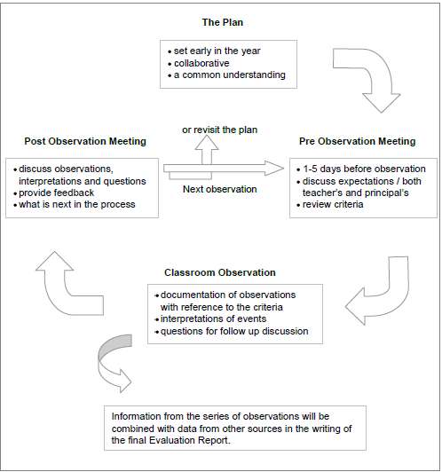

Principal Growth and Evaluation

Principals are to be evaluated in their first and second years and every 3 years after.
Principals not involved in an evaluation process are to be working on a professional growth plan.
All principals in Northwest Territories schools will be evaluated on a regular basis to ensure they possess the skills, knowledge and attitude necessary to lead a school. All new and beginning principals are to be involved in an evaluation process. It is expected that continuing principals will be evaluated at least once every three years. The decision to involve a principal in an evaluation process is made by the Superintendent. This decision may occur at any point in a principal’s term.

New Principals and Principals New to the Jurisdiction

Proposed time-line - Year One

Prior to School Year start
Meet to ensure an understanding of the Evaluation process and expectations for the year.
Sept. - Oct. Reality check (school visit)
Discussions to be held on school operations, program and management expectations and the evaluation process. Supports are identified.
Nov. - Feb. Touch base (school visit)
Observe and discuss school operations. Review school plans, goals, challenges and support needs. Discussion on aspects of Governance (Ed Act), directives and program documents should take place. Also discuss the evaluation process and the collection of evidence.
May - June Reflection
May use self-evaluation based on the profile as a point of discussion. The outcome will be feedback (written) from the supervisor / superintendent based partly on collected evidence. The feedback will include direction for School Improvement Planning and professional development.

Evaluation Process* - Year One
* A formal written evaluation will normally be provided in the second year of this process for new principals. The focus for the first year will be on ensuring an understanding of the role of principal, the identification of knowledge and skill requirements and support in the role. An exception may be made for principals filling a one year term position or for those requesting a formal written evaluation after one year.
Support and ongoing supervision will be provided by the superintendent and/or supervisor of schools.

The process will include a schedule of school visits, discussions on the role and expectations and the development of administration and school plans.

Goals for the year include:
Ensuring an understanding of the principal’s role and responsibilities;
Setting up an Administration plan for the year that may include:
Entry planning (if new to the school/position);
A schedule for key document review (Ed Act, Directives etc.); and
School plan requirements / identification of support strategies.

Beginning a dialog on school leadership;

Beginning the collection of evidence related to the evaluation process; and

Written feedback will be provided to the principal towards the end of this first year. In most cases this will not be the final evaluation report but a summary of the process will be placed on a principal’s personnel file.

Proposed time-line - Year Two
Aug. - Sept. No Surprises
Go over the evaluation plan including: expectations, schedule of events and the identification of evidence to be gathered for this process. Review the Administration Plan and/or School Improvement plans and goals.
Nov. - Jan. (School Visit) Check In
Review the evaluation plan, check evidence gathering, discuss any concerns that surface. This may be a time that the superintendent / supervisor is involved in evidence gathering (surveys etc.). This is also a time to revisit support requirements and supports provided.
April - June (School Visit) Draft Evaluation
Go over evidence gathered and discuss the principal’s reflection. Provide feedback (verbal) on the evaluation to date (a summary of the report that will follow).
June – October Final
A written draft will be shared with the principal for discussion prior to the final report. A copy of the final report will be given to the principal for signing and will be placed on the principal’s personnel file. The principal may wish to attach comments to the final report.

Evaluation Process for Experienced Principals (Year 2 for New Principals)
For new principals ongoing support and supervision is continued.
For a year five (or more) evaluation for a continuing principal, a previous formal evaluation will have made recommendations for growth in certain areas and this evaluation may focus more specifically on those areas previously identified.
The collection of evidence and data to support the evaluation report will continue. It is recommended that the principal create a portfolio to demonstrate activities and actions over the evaluation period.
A written evaluation using criteria described in the Principal Profile (Dimensions) will be produced by the superintendent. The report will be supported by data and observations through school visits, discussions and the collection of evidence.
The purpose of the evaluation is:
To determine and document a basic competence*;
To assess performance and provide feedback for professional growth;
To continue a dialog about school leadership; and
To promote an understanding of the importance of change leadership.
A draft report will be discussed with the principal prior to a final report being placed on the principal’s personnel file.

Northwest Territories Teachers’ Association (NWTTA)

NWT Teacher Qualification for Certification
The NWT Teacher Qualification Service consists of two people appointed by the Department of Education, Culture and Employment and two members recommended by the NWTTA.
Members of the committee establish policies and procedures for:
Certification and recertification of teachers;
Certification and recertification of teachers holding certificates of eligibility as principal;
Evaluation of the qualifications and teaching experience of teachers for the purpose of placing each teacher at a salary level;
Approval of a teacher’s educational qualifications from a post-secondary education institution;
Renewal of expired teaching certificates;
Renewal of teaching certificates where the holder has not completed the teaching experience or courses required;
Extension of time required to meet the requirements of these regulations; and
Qualifications of school counsellors.

For more information on NWT Teacher Qualification Services OR to seek NWT Teacher Certification, c
onsult the Education Act – OR–
Contact the Government of the Northwest Territories Department of Education, Culture and Employment:
NWT Teacher Certification Registrar:
Simon Lepage
Email: simon_lepage@gov.nt.ca

Phone: 867-874-2084
Fax: 867-874-3321

NOTE: The application package for Teacher Certification and Salary Evaluation is available on the GNWT website.
PD Log Recertification Form: Teaching Certificate Recertification PD Statement
Teacher (PDF) add hyperlinks
Principal (PDF)

Code of Ethics – Bylaw 16

PREAMBLE
This Code of Ethics sets out general rules governing the allegation and conduct of members of the Association. Observance of the Code of Ethics is required to maintain high standards of professional service and to ensure that members of the Association conduct themselves in a professional manner in their interactions with students, the public, the Association, other members of the Association and the employer.
Members of the Association are required to conduct themselves, speak and act towards students, the public, the employer, the Association and other members of the Association in a respectful manner, always mindful of the rights and responsibilities of the persons with whom they are dealing and of their own rights and responsibilities.

MEMBER-STUDENT RELATIONS
- The member‘s first responsibility is to the students in his or her charge.
- The member keeps in mind that the intellectual, moral, physical and social welfare of his or her students is the chief aim and end of education.
- When discussing with his or her class controversial matters, whether political, religious or racial, the member keeps his or her teaching as objective as possible.
- The member keeps in mind that a privileged relationship exists between the teacher and his or her students and refrains from exploiting that relationship for material or other advantage.
- Members of the Association recognize and respect the confidential nature of information concerning students and do not divulge, other than through official channels, to authorized persons, officials or agencies directly concerned with student welfare, any information of a personal or domestic nature concerning the student or the student‘s home.
- Members of the Association respect the individual rights, the ethnic traditions and the religious beliefs of their students and of the parents of their students.
- Before accepting a student for private tutoring, a member shall seek and obtain the consent of the student‘s regular teacher.
- Except in exceptional circumstances, a member shall not accept remuneration for tutoring his or her own students.

MEMBER-ASSOCIATION RELATIONS
- It is the right and responsibility of members to participate in, be informed of and inform themselves of Association business and, where appropriate, to make such informed criticisms as the facts appear to warrant.
- Members of the Association shall not, as an individual or as a member of a group of teachers, make unauthorized representations to employers or outside bodies in the name of the Association or in the name of a Local Association or Regional Association.
- Members of the Association shall not, as an individual or as a member of a group of teachers, make unauthorized representations to the Central Executive of the Association concerning matters appropriately dealt with by a Local Association or by a Regional Association.
- Members of the Association shall acknowledge and respect the authority and responsibilities of the Association and its officers, and shall not conduct themselves in a manner prejudicial to the collective bargaining strategies or other interests of the Association.
- Members of the Association shall cooperate with the Association in connection with the investigation of all complaints of professional misconduct.
- Members of the Association shall cooperate with the Association in connection with the investigation and processing of grievances under the collective agreement, and shall honour commitments in that regard made on their behalf by the Association.
- Members of the Association shall endeavour to maintain a harmonious and mutually beneficial relationship with the Association.

MEMBER-PUBLIC RELATIONS
- Members of the Association shall, by their conduct and example, endeavour to make the teaching profession attractive in ideals and practices so that worthy people will be attracted to the profession.
- When required to do so, or in other appropriate circumstances, members shall review with the parents/guardians of students the nature of professional services rendered by the member and the practices followed by the member in discharging professional duties.
- A member of the Association who holds public office is entitled to expect and receive a reasonable allowance of release and relief from teaching duties in order to properly fulfill the duties of the office held. However, where the time required to properly fulfill the duties of the office held is such as to constitute an unreasonable interference with the member‘s professional duties, the member shall apply for leave of absence without pay from his or her teaching position.
- Members of the Association are expected to use their best efforts to expand educational opportunities and improve the quality of education in the Northwest Territories.
- Members of the Association shall conduct themselves, speak and act toward members of the public with respect and in a manner so as to maintain the prestige of the profession.

MEMBER-MEMBER RELATIONS
- Members of the Association shall not make undermining, disparaging or defamatory statements concerning the professional competence of other members of the Association except in accordance with the following protocol:
  - Members of the Association shall first direct any criticism of the teaching performance of another teacher to that teacher in private.
  - After informing another teacher in writing of intention to do so, members of the Association may direct criticism of another teacher, in confidence, to appropriate individuals including, but not limited to, Association officers and or staff who may be able to offer advice and assistance on issues concerning the teacher‘s performance and related work.
  - In case of suspected child abuse, members of the Association shall observe the requirements of law in communications with appropriate officials.
- Members of the Association shall not act in a manner, which undermines the confidence of the students of other members.
- In reporting matters harmful to the welfare of the school, members shall observe proper channels of communication and shall exhaust lower levels of authority before proceeding to higher levels of authority.
- Members of the Association shall endeavour to maintain a harmonious and mutually beneficial relationship with other members of the Association.

MEMBER-EMPLOYER RELATIONS
- Members of the Association shall observe the provisions of the collective agreement and shall endeavour to maintain a harmonious and mutually beneficial relationship with the employer.
- Unless otherwise approved by the employer, members of the Association shall not allow non-school activities to infringe upon school time or performance of professional duties.
- Members of the Association may engage in any extra-curricular activity, which is sanctioned by their Principal.
- A Principal may request, but not require, that a member engage in extra- curricular activity beyond duties that are necessarily incidental to the professional obligations of the member under the collective agreement.
- Where a member of the Association undertakes extra-curricular activity, the member should be compensated in the regular school timetable in order that all members bear a proportionate amount of the school program.
- Members of the Association should endeavour to make professional growth and improvement continuous by study, research, travel, conference and attendance at professional meeting within the framework provided by the collective agreement.

Collective Agreements
The Northwest Territories Teachers’ Association (NWTTA) negotiates three collective agreements on behalf of its members.
Depending upon which jurisdiction NWT teachers and administrators work in, they are covered under one of three contracts.
Collective agreements for NWT educational assistants are generally with the Union of Northern Workers (UNW), unless they work for Yellowknife Education District No. 1 (YK1). YK1 Educational assistants are NWTTA members and are covered under the YK1 contract.
Your Collective Agreement:
Determines the terms and conditions of employment;

Defines teacher benefits, wages, rights and responsibilities;

Clarifies the relationship between the teacher, the principal, the Divisional Education Council (DEC) or District Education Authority (DEA) and the superintendent;
Serves all members in the bargaining unit; and
Assists the NWTTA to serve its members.

Government of the Northwest Territories (GNWT)
http://www.nwtta.nt.ca/vm/newvisual/attachments/926/Media/GNWTNWTTA20162020CollectiveAgreementEnglish.pdf
Yellowknife Catholic Schools
http://www.nwtta.nt.ca/vm/newvisual/attachments/926/Media/NWTTAYCSCollectiveAgreement20122016FINAL.pdf
Yellowknife Education District No. 1 (YK1)
http://www.nwtta.nt.ca/vm/newvisual/attachments/926/Media/YK1NWTTACollectiveAgreement20162020English.pdf

Protocols

Conflict Resolution
Conflict happens to everybody. Conflict can be both constructive and destructive, depending on how it is handled. Three of the most common causes of conflict are:
Misunderstandings
Disagreements
Different ways of doing, talking or thinking about things.
It often originates with unclear communications and understanding.
Some of the things that may worsen conflict:
Mistrust
Misunderstanding of others’ words and actions
Stress
Unclear roles and responsibilities
Lack of problem solving
Poor interpersonal and communication skills
Cultural differences

Sample Negative Group Behaviors:
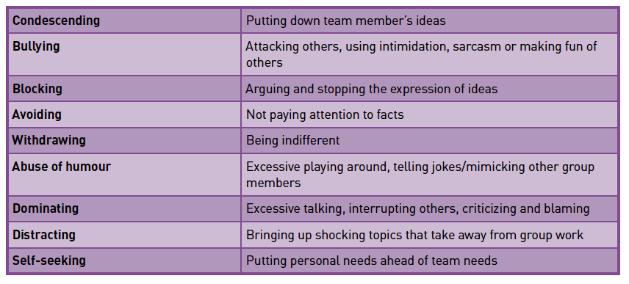
Negative behaviors can cause frustration, anger, withdrawal and a loss of group purpose. Effective teams focus on the positive and everyone works together to accomplish their goals.

Sample Positive Group Behavior: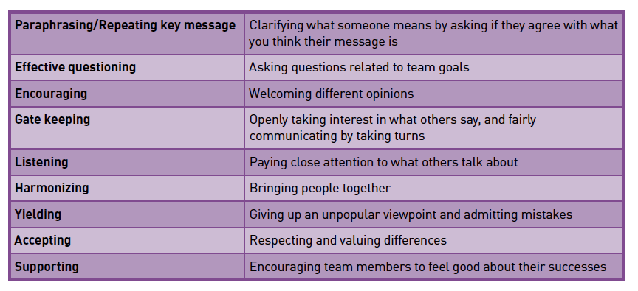

Lines of Communication
Open and respectful communication between all members is very important. There are protocols (rules) which must be used when communicating. When there are concerns or potential conflicts, the following lines of communication should be followed:
Parents → Teachers → Principals → Superintendents
Teachers → Teachers →Local Receiving Officer (LRO) → NWTTA
Principals → Superintendents → Assistant Deputy Minister → Deputy Minister
DEC Chairs →Minister

Professional Development (PD)
In order to maintain an Interim Professional Teaching Certification, a teacher is required to participate in a minimum of 50 hours of professional development during the first three-year term of the certificate. There are regional Professional Development Committees that organize and tend to professional development on a local level.
New and beginning teachers are expected to attend local professional development. Within the Induction and Mentoring programs, PD Committees need to consider offering workshops and courses to allow teachers to connect the theory of pre-service with their teaching experience in the beginning years. Experienced teachers also benefit by refreshing their knowledge and by learning new strategies.

Suggested Professional Areas of Concern for Beginning Teachers:
Multi-level instruction
Differentiated instruction
Long-range planning
Inclusive schooling
Cultural awareness
Creating a positive learning environment
Classroom management
Creative teaching strategies
Student assessment and evaluation
Creating teaching materials
Community involvement
Working with teaching assistants and volunteers
Parental involvement

Department of Education, Culture and Employment
The Department of Education, Culture and Employment offers professional development, in-service and workshops upon request from schools and regions. The workshops are organized into three main categories.
Curricular areas
Assessment
Career Development
On-line learning
Health/Physical Education
Language Arts
Math
Northern Studies/Social Studies
Science
Culture Based Education
Student Support Workshops
Effective Behaviour Support
Inclusive schooling
Healing and recovery
Strategies to help teachers meet student needs

Professional Development Opportunities
Professional improvement is the responsibility of all teachers. Local and regional professional development committees oversee professional development funds used for such activities as workshops, seminars and conferences. A central committee provides funding for learning opportunities such as correspondence courses, summer courses and longer term educational leave.
The NWT Education Leadership Program (ELP) is a two phase course offered to Northerner teachers with at least two years of teaching experience. Phases of the ELP are offered in a chosen Northern community over 10 days during the summer (Phase One during one summer and Phase Two, the following summer). Phases can be completed in any order. When an educator has completed both phases of the ELP, they are granted NWT Principal Certification from the NWT Registrar of Teaching Certification. For more information about the ELP, contact Education Operations and Development at (867) 767-9353, Ext. 71262.
Professional Development Funding
Funding for professional development is guided by NWTTA bylaws and terms of the collective agreement. For information regarding professional development opportunities talk to your local committee, your principal or check out the NWTTA web site – http://www.nwtta.nt.ca .
Online Learning
There are a variety of distance learning courses available to teachers. Check with your regional NWT Teachers’ Association representatives or the NWTTA office in Yellowknife to learn about any professional development funding options that might be available.

Advice for Beginning Teachers

Before School Starts
When you accept your new position;
Contact your regional human resources to begin the process of documentation setup;
Request a pre-orientation package from your regional office or your principal;
Register for New to the NWT Educators’ Conference;
Find out if there will be an orientation for new teachers in your region;
Find out about potential housing in your new community; get details in writing;
Ask for information on the mentorship program and your assigned mentor;
Ask your principal for contact people in your new community and their phone numbers/e-mail addresses;
Acquaint yourself with the region where you will be teaching – geography, history, culture (see website list);
Become familiar with the NWT curricula which are relevant for your teaching assignment (See NWT Information section, NWT Web-sites);
Begin to prepare for your teaching assignment;
Gather useful and relevant teaching resources – posters, stickers, pencils, etc.; and
Become familiar with the details of the contract.

When you arrive in your new community:
It is beneficial to arrive one to two weeks before school begins to allow time to adjust to your new home, community, culture and environment;
Introduce yourself to adults and children in the community – be visible and friendly;
Explore the community and find out about local services;
Arrange to get keys to the school; and
Contact teachers or community people you have been in touch with already prior to arrival.

When you arrive at your new school:
Set up your classroom in advance;
Get to know your materials by reviewing the program of studies, relevant curriculum guides, teacher manuals and your students’ records;
Set up your classroom as a comfortable and inviting learning environment for you and your students; and
Find out about the policies and procedures or your school. These items may be included in a staff handbook or in a staff orientation, but, if not, ask your mentor or principal.

Procedures you need to know:
Every school has a set of procedures that you will need to know prior to the first day of school. Set up a time with your principal to discuss the following list of procedures – you may need to set up a training time for some of them.
Registration procedures, class lists, enrollment forms  Expectations for first day  Electronic grade book  Electronic attendance  Opening exercises and school assemblies  School-wide rules, i.e., attendance policy, school arrival and dismissal times  School keys and security  Timetables  Student fees, supplies textbooks, workbooks  Student computer use | Supervision duties  Substitute teachers  Photocopies  Paper, supplies and budget for additional supplies  Student evaluation  Library resources for students/teachers  Field trips  Fire drills  Lock down procedures  Staff meetings  Calendar of events for the year

Advice from NWT Teachers
Ken Ryan’s guide to surviving the first year of teaching:
Before you begin the first year of teaching, decide to teach a second year.
If you are not organized, get organized.
Do not look for love in the classroom. Look for respect. Look for student achievement. The new teacher who is looking for love is vulnerable and erodes the authority needed to lead a class.
Love the school secretary (and maintenance staff).
Focus on learning.
Become a member of the staff. Colleagues can provide a great source of satisfaction and professional learning.
Pay your body its dues
Come to terms with your authority.
Do not get married the week before school starts.
Find a mentor – an experienced teacher who is willing to act as a guide and a confidant through the year.
Living Advice
Have lots of energy – it‘s hard work.
Have a positive attitude.
Take breaks once in a while.
Be prepared: come with eyes wide open.
Find out about your community.
Secure adequate long-term accommodation.
Once in the community, keep busy by getting involved in the community.
Be adventurous and independent.
Come as a learner and a teacher.
Do more listening than talking.
Teaching Advice
Whatever rules you and your class decide upon, make sure you word them in the POSITIVE...e.g. "Always walk when in the classroom" rather than "Don't run in the classroom" or "Use inside voices when in the classroom" rather than "No shouting or yelling in the classroom"--- Children hear the words "run", "shout" and "yell" in their head, forget the rest of the words and end up running, shouting and yelling.
Be willing to accept the challenge; it is lots of hard work.
Be very flexible: willing to try new things personally and professionally .
Be diplomatic and learn to go with the flow.
Don‘t take things personally, be thick skinned.
Don‘t expect too much from yourself: there’s room for improvement.
Get organized early in the year, set up your filing systems, class lists, storage routines right at the start of the year.
Be ready to work with individual differences.
Be prepared to adapt the curriculum to the academic needs of your students.
Leave all your preconceived notions about cultures at home; accept people the way they are and don‘t try to change things.
Be patient and be willing to adapt.
Move on from negative incidents and be positive.
Don‘t be afraid to ask questions, everyone has gone through a new experience at some time.
Take advantage of the quality professional development opportunities.
File samples of student work at various times during the year. It will help you judge the progress your students make over the year.
Take the students from where they are and celebrate progress.

Travel Advice
Make sure you bring in food supplies for the first day or so. You may arrive after the community store has closed and there may not be any place that serves food after hours.
If you are traveling in the winter by road, bring warm clothes, a sleeping bag, candle and matches, sand, shovel, a tow rope and extra gas. Northern roads are not always well traveled.

Resources

Mentorship – Books and Videos
Brock, B. and Grady, M. (1997) From First-Year to First-Rate: Principals Guiding Beginning Teachers. Thousand Oaks, CA: Corwin Press Inc.
Danielson, C. (1996). How to Help Beginning Teachers Succeed. Alexandria, Virginia: ASCD.
Evertson, C.M. & Smitey, M.W. (2000). Mentoring effects on protégés‘ classroom practice: An experimental field study. The Journal of Educational Research. Vol.93, No. 5.
Gordon, Stephen P. & Maxey, Susan (2000). How to Help Beginning Teachers Succeed 2nd Edition. Association for Supervision and Curriculum Development, Alexandra, VA.
Scherer, M. (1999). A Better Beginning: Supporting and Mentoring New Teachers. Alexandria, VA: ASCD.
Wong, H. (1998). The First Days of School. Sunnyvale, California: Harry K. Wong Publications.
Mentoring the New Teacher. (1994). Alexandria, Virginia: ASCD. (1-800-262-8803) This is a series of nine videotapes using research-based case studies to present actual new and mentor teachers dealing with the most common problems facing new teachers.
The Effective Teacher. Sunnyvale, California: HKW Productions. This is a kit containing a series of eight videotapes.

Internet Sites
Indigenous Resources
Aboriginal Mapping Unit http://www.nativemaps.org/
Arctic Circle http://arcticcircle.uconn.edu/
Dene Kede Curriculum https://www.ece.gov.nt.ca/en/resources?denekede-inuuqatigiit
Innuqatigiit Curriculum https://www.ece.gov.nt.ca/en/resources?denekede-inuuqatigiit

First Nations in Canada http://www.ainc-inac.gc.ca
Native Web http://www.nativeweb.org
Native Tech http://www.nativetech.org
Assessment
Alberta Assessment Consortium (consult board office for member login) http://aac.ab.ca
Rubrics for Teachers http://www.teacherplanet.com/rubrics-for-teachers
Curriculum
Education, Culture and Employment Curricula https://www.ece.gov.nt.ca/en/services/k-12-education-and-curriculum
Teachers First www.teachersfirst.com/matrix.cfm
Western and Northern Canadian Protocol www.wncp.ca
Mentoring
Mentors Peer Resources (Canadian) http://www.mentors.ca/mentor.html
The Mentoring Group http://www.mentoringgroup.com/html/archive.html
Living and Teaching in the Northwest Territories
Community information http://www.maca.gov.nt.ca
NWT Library Services http://nwtpls.gov.nt.ca
Spectacular Northwest Territories http://www.spectacularnwt.com
Travel Information http://www.travel.org/nw-terri.html
Transportation information http://www.dot.gov.nt.ca/

Northwest Territories Teachers’ Association www.nwtta.nt.ca
Media Awareness and Digital Literacy
MediaSmarts https://mediasmarts-k12-nwt.wikispaces.com/
Education Renewal in the NWT/Renouveau en éducation aux TNO
Directions for Change (Eng) https://www.ece.gov.nt.ca/en/services/education-renewal

Nouvelles Orientations (Fre) https://www.ece.gov.nt.ca/fr/services/renouveau-en-education-aux-tno

References

A Guide to Principal Practice: Principal Growth and Evaluation in the Northwest Territories. (2012). Northwest Territories Education, Culture and Employment

DEA and DEC Member Handbook. (2016-2017). Government of Northwest Territories

Departmental Directive on Aboriginal Language and Culture Based Education. (2004). Northwest Territories Education, Culture and Employment.

Educating All our Children: Departmental Directive on Student Assessment, Evaluation, and Reporting (2010). Northwest Territories Education, Culture and Employment.

Education Renewal and Innovation Framework: Directions for Change. (2013). Northwest Territories Education, Culture and Employment.

Evaluation and Promotion of Professional Growth for Teachers in NWT Schools. (2004). Northwest Territories Education, Culture and Employment.

NWT Ministerial Directive on Inclusive Schooling. (2016). Guidelines for Inclusive Schooling: Supporting the NWT Ministerial Directive on Inclusive Schooling.

NWT Teacher Induction: A Program for Beginning Teachers. (2002). Northwest Territories Education, Culture and Employment

As part of the GNWT’s Education Renewal and Innovation (ERI) initiative, this Directive is being renewed, but will remain in place until the renewed directive is released in 2018/19.

